Web Programming Languages

CSC-XXX
Semester 7th
Name: KHIZER ALAM
ID Number: IU04-0321-0519
Department of Computer Science
IQRA University, Karachi

List of Experiments
Weekly Plan
Week No | Topics covered | Remarks
1 | HTML tags and structure overview. Implementation of basic HTML to make a webpage. | CLO 1,2,3
2 | Implementation of the multiple tags table,thead,tbody,tr,th in HTML and built a basic table. | CLO 1,2,3
3 | Implementation of the “form” tag in HTML with different input type elements like, text, number, file, radio, email, password, and dropdown using select tag and design a form. | CLO 1,2,3
4 | Explored the fundamentals of Bootstrap and implemented it’s classes on forms and tables. | CLO 1,2,3
5 | Introduction to JavaScript. Explored the JavaScript function integration with HTML. Implementation of Data Set and Data Get | CLO 1,2,3
6 | Learned about validation of HTML inputs through conditional statements and regular expressions in JavaScript. | CLO 1,2,3
7 | Introduction to backend language, Introduction to PHP global arrays, Implementation of HTTP Methods ($_GET and $_POST). Data set and data get from backend to frontend and vice versa. Also, studied XAMPP and MySQL Database.  different | CLO 1,2,3
8 | Studied the basics of CRUD operations and performed “create” operation. and read operation and fetched data from the database using queries DDL and DML queries. | CLO 1,2,3
9 | Implementation of CRUD operations further, and studied the functionalities of update and delete using queries in PHP. | CLO 1,2,3
10 | Introduction to jQuery, implementation of different javascript events like onclick, onblur, onkeyup etc. Also, learned about the differences between XML and JSON, also implemented CRUD operations using AJAX. | CLO 1,2,3
11 | Implemented master template using include in PHP and studied Sessions. | CLO 1,2,3
12 | Learned about version control (git) and explored GitHub. Project creation, Project clone, data pull and push with in the project. | CLO 1,2,3
13 | Introduction to SQL Injection and it’s prevention. And, project evaluation and PBL submission | CLO 1,2,3
14
Final Examination

Rubric for Assessment (Software)

Criteria | Exceeds Expectations (>=88%) | Meets Expectations (74%-87%) | Developing (60%-73%) | Unsatisfactory (<60%)
Software Skills | Ability to use software with its standard and advanced features without assistance | Ability to use software with its standard and advanced features with minimal assistance | Ability to use software with its standard features with assistance | Unable to use the software
Programming/ Simulation | Ability to program/ simulate the lab tasks  with simplification | Ability to program/ simulate the lab tasks  without errors | Ability to program/ simulate lab tasks with errors | Unable to program/simulate
Results | Ability to achieve all the desired results with alternate ways | Ability to achieve all the desired results | Ability to achieve most of the desired results with errors | Unable to achieve the desired results
Laboratory Manual | All sections of the report are very well written and technically accurate. | All sections of the report are technically accurate. | Few sections of the report contain technical errors. | All sections of the report contain multiple technical errors.

Rubric for Assessment (Affective)

Criteria | Exceeds Expectations (>=88%) | Meets Expectations (74%-87%) | Developing  (60%-73%) | Unsatisfactory (<60%)
Attitude & Enthusiasm | Shows strong interest, curiosity, and enthusiasm for lab tasks; actively explores beyond requirements. | Displays interest and motivation; completes tasks with a positive attitude. | Completes tasks with minimal enthusiasm; does not explore beyond given requirements. | Shows little interest or motivation; engages only when required.
Teamwork & Collaboration | Actively contributes, respects peers, and encourages a cooperative environment. | Works well with peers and contributes to group tasks. | Participates when prompted but does not take initiative in group work. | Minimal contribution; may disrupt teamwork.
Ethical Conduct & Academic Integrity | Demonstrates integrity, follows all ethical guidelines, and ensures originality in work. | Follows ethical guidelines with minor lapses. | Occasionally needs reminders to maintain academic integrity. | Displays unethical behavior such as copying or disregarding integrity guidelines.
Respect for Lab Rules & Safety | Strictly follows lab rules, respects equipment, and ensures safety measures are met. | Follows lab rules and safety guidelines with minimal reminders. | Occasionally disregards lab rules or safety protocols. | Frequently ignores lab rules or misuses equipment.
Communication & Professionalism | Communicates ideas clearly, respects peers and instructors, and uses professional language. | Communicates effectively with minor lapses in professionalism. | Occasionally struggles with professional communication. | Poor communication skills; lacks professionalism in interactions.

Criteria | Excellent  ( 5 Marks ) | Good  ( 4 Marks ) | Satisfactory  (3 Marks ) | Needs Improvement  (2 Marks ) | Total Marks
Problem Understanding &  Approach | Clearly defines the problem, explores multiple approaches, and justifies the chosen method logically. | Understands the problem well, considers different approaches, and explains the method adequately. | Shows basic understanding but lacks exploration of different methods. | Limited understanding of the problem, incorrect or unclear approach.
Select Appropriate Method & Tools | Relevant and smart selection of equipments and tools to achieve desired objective along with proper reasoning. | Satisfactory selection of equipments and tools to achieve desired objective along with proper reasoning. | Satisfactory selection of equipments and tools to achieve desired objective without proper reasoning. | Unsatisfactory selection of equipment’s and tools to achieve desired objective.
Implementation | Code is efficient, well-structured, and follows best practices (e.g., modularity, readability, comments). | Code is mostly well-structured, with minor inefficiencies or readability issues. | Code runs but lacks structure, comments, or efficiency. Some redundant or unclear code. | Code is incomplete, difficult to follow, or does not run correctly.
Results & Analysis | Clearly presents results with insightful analysis, visualizations (if applicable), and interpretation. | Results are well presented with a reasonable explanation, but analysis could be deeper. | Results are provided but lack detailed analysis or proper explanation. | Poorly presented results, missing analysis or incorrect conclusions.

Problem Based Learning Lab Rubrics

Formula: Total marks/20*10
Marks Obtained: out of ____10_____ Examined by:

Open Ended Lab Rubrics

Formula: Total marks/20*10

Marks Obtained: out of _10 Examined by: _________________

Criteria | Excellent  ( 5 Marks ) | Good  ( 4 Marks ) | Satisfactory  (3 Marks ) | Needs Improvement  (2 Marks ) | Total Marks
Problem Understanding &  Approach | Clearly defines the problem, explores multiple approaches, and justifies the chosen method logically. | Understands the problem well, considers different approaches, and explains the method adequately. | Shows basic understanding but lacks exploration of different methods. | Limited understanding of the problem, incorrect or unclear approach.
Select Appropriate Method & Tools | Relevant and smart selection of equipments and tools to achieve desired objective along with proper reasoning. | Satisfactory selection of equipments and tools to achieve desired objective along with proper reasoning. | Satisfactory selection of equipments and tools to achieve desired objective without proper reasoning. | Unsatisfactory selection of equipments and tools to achieve desired objective.
Implementation | Code is efficient, well-structured, and follows best practices (e.g., modularity, readability, comments). | Code is mostly well-structured, with minor inefficiencies or readability issues. | Code runs but lacks structure, comments, or efficiency. Some redundant or unclear code. | Code is incomplete, difficult to follow, or does not run correctly.
Results & Analysis | Clearly presents results with insightful analysis, visualizations (if applicable), and interpretation. | Results are well presented with a reasonable explanation, but analysis could be deeper. | Results are provided but lack detailed analysis or proper explanation. | Poorly presented results, missing analysis or incorrect conclusions.

Score Allocation
S.No | Software Skills: | Programming / Simulation | Results: | Laboratory Manual: | Score:
1 | (___) /3 | (___) /2 | (___) /3: | (___) /2 | (___) /10
2 | (___) /3 | (___) /2 | (___) /3: | (___) /2 | (___) /10
3 | (___) /3 | (___) /2 | (___) /3: | (___) /2 | (___) /10
4 | (___) /3 | (___) /2 | (___) /3: | (___) /2 | (___) /10
5 | (___) /3 | (___) /2 | (___) /3: | (___) /2 | (___) /10
6 | (___) /3 | (___) /2 | (___) /3: | (___) /2 | (___) /10
7 | (___) /3 | (___) /2 | (___) /3: | (___) /2 | (___) /10
8 | (___) /3 | (___) /2 | (___) /3: | (___) /2 | (___) /10
9 | (___) /3 | (___) /2 | (___) /3: | (___) /2 | (___) /10
10 | (___) /3 | (___) /2 | (___) /3: | (___) /2 | (___) /10
11 | (___) /3 | (___) /2 | (___) /3: | (___) /2 | (___) /10
12 | (___) /3 | (___) /2 | (___) /3: | (___) /2 | (___) /10
Total Obtained Score |  |  |  |  | (___)120

Formula= (Total Obtained Score / 120) x 15 Examined by:
___ Score: ___________ out of 15 (Signature of Instructor)

Instructor:
Prerequisites: Web Programming Languages
Course Description:
This course provides an in-depth study of advanced concepts in relational and non-relational database systems, focusing on enterprise-level database design, implementation, and administration. Students will explore advanced SQL techniques, schema design, data integrity, indexing, transaction management, and performance optimization.
The course emphasizes practical skills in stored procedures, triggers, views, backup & recovery, concurrency control, and security mechanisms, preparing students to design robust, scalable, and secure database systems suitable for modern applications. Students will also gain hands-on experience in implementing audit trails, cascading actions, and advanced query optimization.

Course Contents:
Learning Outcomes:
Mapping of CLOs and GA
Sr. No. | Course Learning Outcomes (CLOs) | GA | Bloom’s Taxonomy
CLO 1 | Practice | GA2 | C3 (Application)
CLO 2 | Perform the development of solutions for complex engineering problems utilizing the techniques used in labs to design a project. | GA6 | A2 (Respond)

Assessment tools | CLO_1 | CLO_2 | Total
Lab Performance/Manual | 11% | 4% | 15%
Final Examination | 30% | 10% | 40%

Overall Grading Policy
Assessment Items | Percentage
Lab Performance/ Lab Manual/OEL/PBL/Project | 60%
Final Examination | 40%
Recommended Book:

Reference Book:

Administrative Instructions:
- According to institute policy, 75% attendance is mandatory to appear in the final examination but 100% will be expected. Approved leaves will not be considered towards attendance. Every student should bring manual and notebook in each lab.
- Every student is expected to be in lab before schedule starting time.
- In any case there will be no rescheduling and makeup of labs.

General Laboratory Procedure
While there is no specific document to be submitted at the beginning of the Lab –unless your instructor advises you otherwise-, you are expected to read the experiment fully before you come to the laboratory? Interestingly, you can even try parts of the experiment at home. Here is a list of programs that will equip you with a virtual lab at your home:
Troubleshooting
Things will not always go as expected; this is the nature of the learning process. While conducting the Experiment think before you do anything. If you do so you will avoid wasting time going down dead-end streets. Be logical and systematic. First, look for obvious errors that are easy to fix. Is your measuring device correctly set and connected? Are you looking at the proper scale? Is the power supply set for the correct voltage? Is the signal generator correctly set and connected? How are the variables in the code set? Is there a syntax error? And so on. Next, check for obvious misconnections or broken connections, at least in simple circuits.
As you work through your circuit, use your Lab Manual record tests and changes that you make as you go along; don't rely on your memory for what you have tried. Identify some test points in the system at which you know what the signal should be and work your way backwards from the output through the test points until you find a good signal.
Neatness
When you have finished for the day, return all modules to their proper storage bins, return all test leads and probes to their storage racks, return all equipment to its correct location, and clean up the lab station. If appropriate switch off the unneeded equipment. Save your files in the Computer and on any USB device for your records because you might not get the same PC System again for the next experiment. Also email your file contents to your email address as a backup.
Laboratory Safety

Always pay attention to what you are doing and you’re surrounding during the experiments, notify the Instructor for any unlikely event or mishap, and leave the Laboratory with the permission of Instructor immediately.
All students must read and understand the information in this document with regard to laboratory safety and emergency procedures prior to the first laboratory session.
Your personal laboratory safety depends mostly on YOU. Efforts have been made to address situations that may pose a hazard in the lab but the information and instructions provided cannot be considered all-inclusive.
Students must adhere to written and verbal safety instructions throughout the academic term. Since additional instructions may be given at the beginning of laboratory sessions, it is important that all students arrive at each session on time. With good judgment, the chance of an accident in this course is very small. Nevertheless, research and teaching workplaces (labs, shops, etc.) are full of potential hazards that can cause serious injury and or damage to the equipment. Working alone and unsupervised in laboratories is forbidden if you are working with hazardous substances or equipment. With prior approval, at least two people should be present so that one can shut down equipment and call for help in the event of an emergency. Safety training and/or information should be provided by a faculty member, teaching assistant, lab safety contact, or staff member at the beginning of a new assignment or when a new hazard is introduced into the workplace.
Emergency Response
- It is your responsibility to read safety and fire alarm posters and follow the instructions during an emergency
- Know the location of the fire extinguisher, eye wash, and safety shower in your lab and know how to use them.
- Notify your instructor immediately after any injury, fire or explosion, or spill.
- Know the building evacuation procedures.
Common Sense
Good common sense is needed for safety in a laboratory. It is expected that each student will work in a responsible manner and exercise good judgment and common sense. If at any time you are not sure how to handle a particular situation, ask your Teaching Assistant or Instructor for advice DO NOT TOUCH ANYTHING WITH WHICH YOU ARE NOT COMPLETELY FAMILIAR!!! It is always better to ask questions than to risk harm to yourself or damage to the equipment. 
Personal and General laboratory safety
- Never eat, drink, or smoke while working in the laboratory.
- Read labels carefully.
- Do not use any equipment unless you are trained and approved as a user by your supervisor.
- Wear safety glasses or face shields when working with hazardous materials and/or equipment.
- Wear gloves when using any hazardous or toxic agent.
- Clothing: When handling dangerous substances, wear gloves, laboratory coats, and safety shield or glasses. Shorts and sandals should not be worn in the lab at any time. Shoes are required when working in the machine shops.
- If you have long hair or loose clothes, make sure it is tied back or confined.
- Keep the work area clear of all materials except those needed for your work. Coats should be hung in the hall or placed in a locker. Extra books, purses, etc. should be kept away from equipment that requires air flow or ventilation to prevent overheating.
- Disposal - Students are responsible for the proper disposal of used material if any in appropriate containers.
- Equipment Failure - If a piece of equipment fails while being used, report it immediately to your lab assistant or tutor. Never try to fix the problem yourself because you could harm yourself and others.
- If leaving a lab unattended, turn off all ignition sources and lock the doors.
- Never pipette anything by mouth.
- Clean up your work area before leaving.
- Wash hands before leaving the lab and before eating.
- Unauthorized person(s) shall not be allowed in a laboratory for any reason
Electrical safety
- Obtain permission before operating any high voltage equipment.
- Maintain an unobstructed access to all electrical panels.
- Wiring or other electrical modifications must be referred to the Electronics Shop or the Building Coordinator.
- Avoid using extension cords whenever possible. If you must use one, obtain a heavy- duty one that is electrically grounded, with its own fuse, and install it safely. Extension cords should not go under doors, across aisles, be hung from the ceiling, or plugged into other extension cords.
- Never, ever modify, attach or otherwise change any high voltage equipment.
- Always make sure all capacitors are discharged (using a grounded cable with an insulating handle) before touching high voltage leads or the "inside" of any equipment even after it has been turned off. Capacitors can hold charge for many hours after the equipment has been turned off.
- When you are adjusting any high voltage equipment or a laser which is powered with a high voltage supply, USE ONLY ONE HAND. Your other hand is best placed in a pocket or behind your back. This procedure eliminates the possibility of an accident where high voltage current flows up one arm, through your chest, and down the other arm.
- Discard damaged cords, cords that become hot, or cords with exposed wiring.
- Before equipment is energized ensure, (1) circuit connections and layout have been checked by a Teaching Assistant (TA) and (2) all colleagues in your group give their assent.
- Know the correct handling, storage and disposal procedures for batteries, cells, capacitors, inductors and other high energy-storage devices.
- Experiments left unattended should be isolated from the power supplies. If for a special reason, it must be left on, a barrier and a warning notice are required.
- Equipment found to be faulty in any way should be reported to the Lab Engineer immediately and taken out of service until inspected and declared safe.
- Voltages above 50 V rms AC and 120 V DC are always dangerous. Extra precautions should be considered as voltage levels are increased.
- Never make any changes to circuits or mechanical layout without first isolating the circuit by switching off and removing connections to power supplies.
- Know what you must do in an emergency.
- Emergency Power Off: Every lab is equipped with and Emergency Power Off System.
- Only authorized personnel are permitted to reset power once the Emergency Power Off system has been engaged.
Electrical Emergency Response
The following instructions provide guidelines for handling two types of electrical emergencies:
- When someone suffers serious electrical shock, he or she may be knocked unconscious. If the victim is still in contact with the electrical current, immediately turn off the electrical power source. If you cannot disconnect the power source, depress the Emergency Power Off switch.
- Do not touch a victim that is still in contact with a live power source; you could be electrocuted.
- Have someone call for emergency medical assistance immediately. Administer first-aid, as appropriate.
- If an electrical fire occurs, try to disconnect the electrical power source, if possible. If the fire is small and you are not in immediate danger; and you have been properly trained in fighting fires, use the correct type of fire extinguisher to extinguish the fire. When in doubt, push in the Emergency Power Off button.
- NEVER use water to extinguish an electrical fire.
Mechanical safety
- When using compressed air, use only approved nozzles and never direct the air towards any person.
- Guards on machinery must be in place during operation.
- Exercise care when working with or near hydraulically- or pneumatically-driven equipment. Sudden or unexpected motion can inflict serious injury. 
Additional Safety Guidelines
- Never do unauthorized experiments.
- Never work alone in laboratory.
- Keep your lab space clean and organized.
- Do not leave an on-going experiment unattended.
- Always inform your instructor if you break a thermometer. Do not clean mercury yourself!!
- Never taste anything. Never pipette by mouth; use a bulb.
- Never use open flames in laboratory unless instructed by TA.
- Check your glassware for cracks and chips each time you use it. Cracks could cause the glassware to fail during use and cause serious injury to you or lab mates.
- Maintain unobstructed access to all exits, fire extinguishers, electrical panels, emergency showers, and eye washes.
- Do not use corridors for storage or work areas.
- Do not store heavy items above table height. Any overhead storage of supplies on top of cabinets should be limited to lightweight items only. Also, remember that a 36" diameter area around all fire sprinkler heads must be kept clear at all times.
- Areas containing lasers, biohazards, radioisotopes, and carcinogens should be posted accordingly. However, do not post areas unnecessarily and be sure that the labels are removed when the hazards are no longer present.
- Be careful when lifting heavy objects. Only shop staff may operate forklifts or cranes.
- Clean your lab bench and equipment, and lock the door before you leave the laboratory.
Clothing
- Dress properly during a laboratory activity.
- Long hair, dangling jewelry, and loose or baggy clothing are a hazard in the laboratory.
- Long hair must be tied back, and dangling jewelry and baggy clothing must be secured.
- Shoes must completely cover the foot.
- No sandals allowed on lab days.
- A lab coat or smock should be worn during laboratory experiments.
Accidents and Injuries
- Do not panic.
- Report any accident (spill, breakage, etc.) or injury (cut, burn, etc.) to the teacher immediately, no matter how trivial it seems.
- If you or your lab partner is hurt, immediately (and loudly) yell out the teacher's name to get the teacher's attention.

General Warning Signs

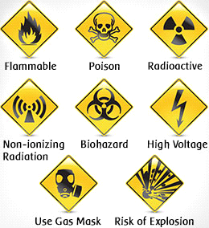

LAB # 1

Objective:
Students will learn to create a basic HTML webpage to display personal information in the form of a resume/CV.

Learning Outcomes:
By completing this lab, students will be able to:
- Understand the basic structure of an HTML document
- Use HTML heading tags (h1, h2, h3)
- Apply text formatting tags (b, u)
- Create lists using <li> tags
- Add hyperlinks using anchor tags
- Use horizontal rules and paragraph tags
- Center align content using the <center> tag

Task:
Create a single-page HTML resume/CV that includes the following sections:
- Personal Information (centered at the top):
  - Full Name
  - Professional Title/Designation
  - Email Address
  - Contact Number
- Professional Summary:
  - A brief paragraph (3-4 lines) describing yourself and your professional expertise
- Education:
  - List your educational qualifications in reverse chronological order
  - Include: Degree name, Institution name, and years attended
- Experience:
  - List your work experience (at least 2 entries)
  - Include: Job title, Company name, and duration
- Skills:
  - List at least 6-8 technical skills relevant to your field
- Reference:
  - Add at least one hyperlink (e.g., GitHub, LinkedIn, or personal portfolio)

Requirements:
- Use proper HTML document structure (<HTML>, <head>, <title>, <body>)
- Use appropriate heading tags for section titles
- Apply text formatting (bold, underline) where necessary
- Use horizontal rule (<hr>) to separate the header section
- All HTML tags must be properly opened and closed

CODE:
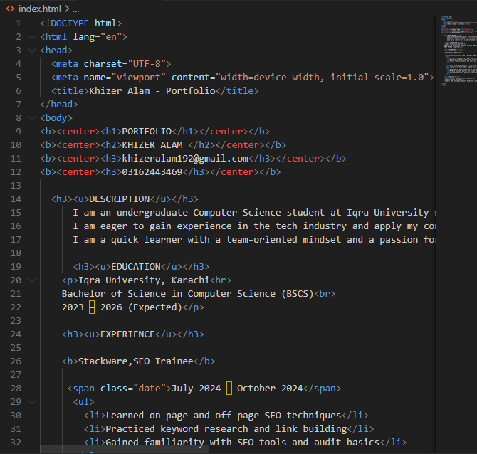
<h3>Remote Car Detailing Sales — Freelance Sales Assistant</h3>
<span class="date">Part-time / Remote</span>
<ul>
<li>Promoted car detailing services through Facebook groups</li>
<li>Handled customer queries and closed sales remotely</li>
<li>Coordinated service delivery and customer follow-up</li>
</ul>

<h3><u>SKILLS</u></h3>
<p>Soft Skills: Communication, Teamwork</p>
<p>Tools: Slack, ClickUp</p>
<p>Basic SEO Knowledge: Keyword Research, Link Building</p>

</body>
</html>

SCREENSHOT:



LAB # 2

Objective:
Students will learn to create structured data tables using HTML table elements.

Learning Outcomes:
By completing this lab, students will be able to:
- Create tables using <table>, <thead>, <tbody>, <tr>, <th>, and <td> tags
- Apply borders to tables
- Organize data in rows and columns
- Use proper HTML5 document structure

Task Description:
Create an HTML page displaying student information in a table format with the following specifications:

Requirements:
- Document Structure:
  - Use HTML5 DOCTYPE declaration
  - Include meta tags for charset (UTF-8) and viewport
  - Add appropriate page title
- Table Structure: Create a table with these columns:
  - Id (Student ID/Roll Number)
  - Name
  - Age
  - Email
  - Contact
- Table Components:
  - Add border="1" attribute to the table
  - Use <thead> for column headers
  - Use <tbody> for data rows
  - Include at least 3 student records
- Data Format:
  - Use realistic student data
  - Format email addresses properly (e.g., name.id@domain.edu.pk)
  - Use proper phone number format (e.g., 0330-12345678)

CODE:
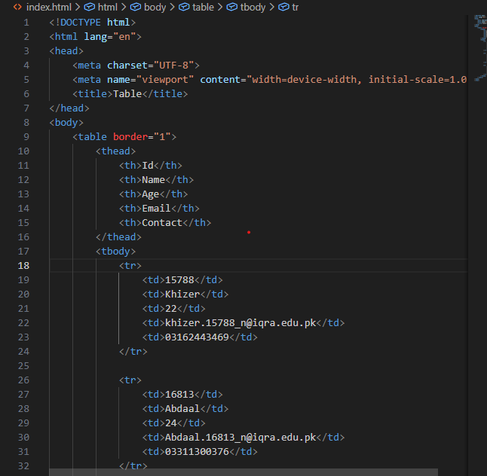
<tr>
<td>15763</td>
<td>Abdullah</td>
<td>23</td>
<td>Abdullah.15763_n@iqra.edu.pk</td>
<td>03311300375</td>
</tr>
</tbody>
</table>
</body>
</html>

SCREENSHOT:
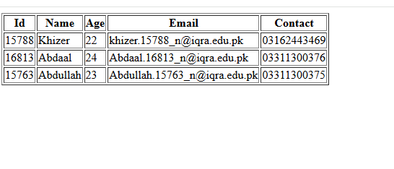

Lab # 3:

Objective:
Students will learn to create interactive HTML forms using various input types and form controls.

Learning Outcomes:
By completing this lab, students will be able to:
- Create forms using the <form> tag
- Use different input types: text, email, number, password, file, date, radio, checkbox, button
- Apply labels to form elements
- Implement radio buttons for single selection
- Implement checkboxes for multiple selections
- Structure forms using div containers

Task Description:
Create an HTML page with a form that collects user information using different types of input fields.

Requirements:
- Document Structure:
  - Use proper HTML DOCTYPE declaration
  - Set page title as "Simple Form"
  - Wrap all input fields inside <form> tags
- Form Fields (Total 9 inputs): Create the following input fields with proper labels:
  - Name - Text input (type="text")
  - Email - Email input (type="email")
  - Contact - Number input (type="number")
  - Password - Password input (type="password")
  - File Picker - File upload (type="file")
  - Date Picker - Date selection (type="date")
  - Gender - Radio buttons with 2 options: Male and Female (same name="gender")
  - Subject - Checkboxes with 3 options: HTML, CSS, JavaScript (individual names)
  - Button - Input button (type="button")
- Form Structure Requirements:
  - Wrap each input field in a separate <div> element
  - Use <label> tag before each input field
  - Add <br> tag after each label
  - Include id and name attributes for all inputs
  - Radio buttons must have value attributes and same name
  - Each checkbox should have unique name matching its subject
CODE:
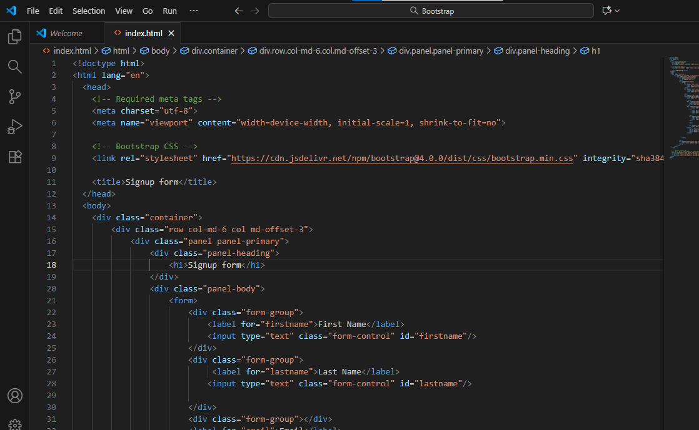
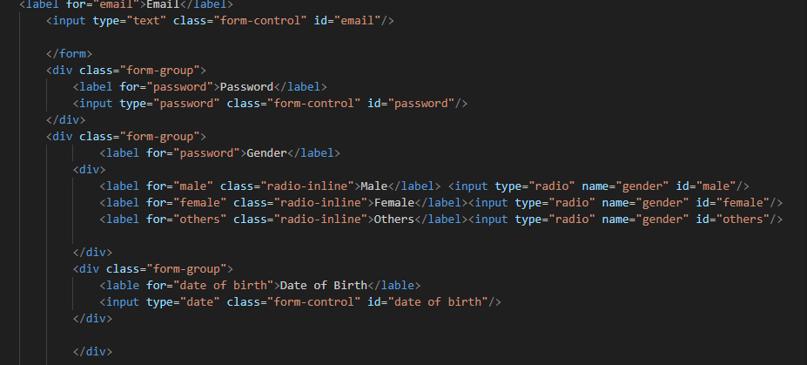
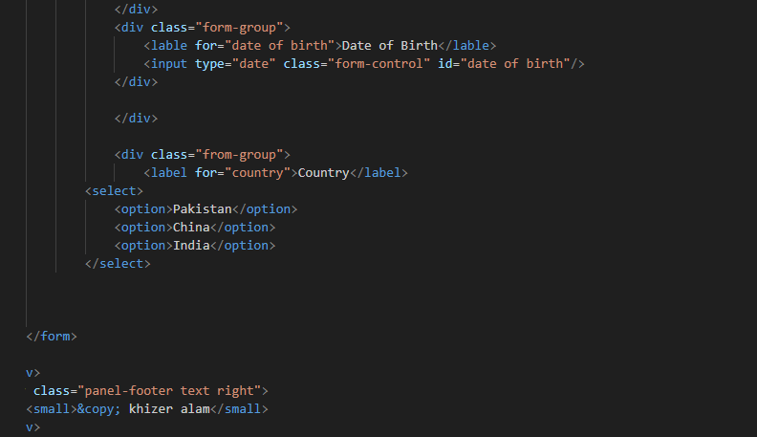

SCREENSHOT:
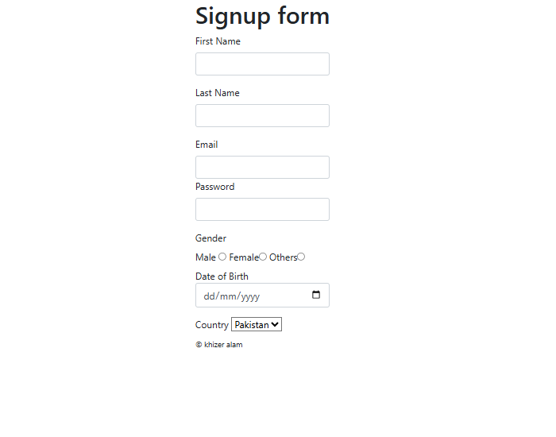

Lab # 4:

Objective:
Students will learn to create a responsive and styled signup form using Bootstrap 5 framework.

Learning Outcomes:
By completing this lab, students will be able to:
- Link external Bootstrap CSS and JavaScript files
- Use Bootstrap grid system (container, row, col)
- Apply Bootstrap form classes (form-control, form-select, form-check)
- Create responsive layouts using Bootstrap components
- Use Bootstrap card component for design
- Implement dropdown select menus
- Style buttons using Bootstrap classes
- Add images to web pages

Task Description:
Create a responsive signup form with Bootstrap styling that includes various form inputs and is displayed alongside an image.

Requirements:
- Document Setup:
  - Use HTML5 DOCTYPE with lang="en"
  - Include meta tags for charset (UTF-8) and viewport
  - Link Bootstrap CSS file: <link rel="stylesheet" href="../bootstrap/CSS/bootstrap.min.CSS">
  - Link Bootstrap JS file: <script src="../bootstrap/JS/bootstrap.bundle.JS"></script>
  - Set page title as "Signup Form"
  - Add class="bg-light" to body tag
- Bootstrap Grid Layout:
  - Use container class with mt-5 (margin-top)
  - Create a row
  - Add two columns using col-md-6 (each taking 50% width on medium+ screens)
- Left Column - Form Section: Create a card component with the following structure:
  - Use card class with mt-3
  - Add card-body inside the card
  - Include centered heading "Signup Form" using text-center and mb-4
- Form Fields (Total 8 inputs in this order): a) Username - Text input with class form-control and placeholder "e.g. Ali Raza" b) Email - Email input with class form-control and placeholder "example@gmail.com" c) Password - Password input with class form-control d) D.O.B - Date input with class form-control e) Contact - Text input with class form-control f) Country - Dropdown (select) with class form-select and options:
  - "Select Country" (selected and disabled)
  - Pakistan
  - USA
  - India (disabled)
  - Russia
- g) Do you agree? - Radio buttons displayed inline with options Yes and No
  - Use form-check-inline class
  - Both radio buttons have same name="agree"
  - Include value attributes (yes/no)
- h) Remember Me - Single checkbox with class form-check-input i) Sign Up Button - Submit button with classes btn btn-success and value="Sign Up"
  - Wrapped in a div with class d-grid
- Bootstrap Form Classes:
  - Use mb-3 class for spacing between all form groups
  - Apply form-control class to all text inputs (username, email, password, dob, contact)
  - Apply form-select class to dropdown
  - Use form-check and form-check-input for checkbox
  - Use form-check-inline for inline radio buttons
  - Apply d-grid to button container for full-width button
- Right Column - Image Section:
  - Add an image with inline style: style="height: 700px;"
  - Use appropriate image file
  - Include alt attribute (can be empty)
- Dropdown Requirements:
  - First option: "Select Country" (must be selected and disabled)
  - Include exactly 4 country options: Pakistan, USA, India, Russia
  - India option must be disabled
- Radio Button Requirements:
  - Both radio buttons must have same name="agree"
  - Include value attributes: value="yes" and value="no"
  - Display inline using form-check-inline
  - Wrap each radio button in a div with classes form-check form-check-inline

Submission Guidelines:
- File name: lab4_bootstrap_form_[YourRollNumber].HTML
- Include the image file used in your submission
- Ensure Bootstrap files are properly linked in "../bootstrap/" folder
- Deadline: [Add your deadline]

Evaluation Criteria:
- Proper HTML5 structure and Bootstrap links (10%)
- Correct Bootstrap grid layout (container, row, col-md-6) (15%)
- Card component with card-body (10%)
- All 8 form inputs with proper Bootstrap classes (30%)
- Dropdown with selected disabled option and one disabled country (10%)
- Inline radio buttons with proper structure (5%)
- Checkbox implementation (5%)
- Button with value and proper styling (5%)
- Image integration with correct height (5%)
- Overall responsive design and spacing (5%)
Total Marks: [Add marks]

Important Bootstrap Classes Used:
- Layout: container, row, col-md-6, mt-5, mt-3
- Form: form-control, form-select, form-check, form-check-input, form-check-label, form-check-inline
- Card: card, card-body
- Button: btn, btn-success, d-grid
- Spacing: mb-3, mb-4
- Text: text-center
- Background: bg-light

Notes:
- Bootstrap must be downloaded and linked locally from "../bootstrap/" folder
- The form uses method="#" which means it won't submit data (for demonstration only)
- The layout is responsive and will stack vertically on smaller screens
- Make sure your image path is correct relative to your HTML file
- The button uses <input type="button"> with a value attribute to display text

CODE:

<!doctype html>
<html lang="en">
<head>

<meta charset="utf-8">
<meta name="viewport" content="width=device-width, initial-scale=1, shrink-to-fit=no">

<link rel="stylesheet" href="https://cdn.jsdelivr.net/npm/bootstrap@4.0.0/dist/css/bootstrap.min.css" integrity="sha384-Gn5384xqQ1aoWXA+058RXPxPg6fy4IWvTNh0E263XmFcJlSAwiGgFAW/dAiS6JXm" crossorigin="anonymous">
<link rel="stylesheet" href="style.css">

<title>Signup form</title>
</head>
<body>
<div class="container">
<div class="row col-md-6 col md-offset-3">
<div class="panel panel-primary">
<div class="panel-heading">
<h1>Signup form</h1>
</div>
<div class="panel-body">
<form>
<div class="form-group">
<label for="firstname">First Name</label>
<input type="text" class="form-control" id="firstname"/>
</div>
<div class="form-group">
<label for="lastname">Last Name</label>
<input type="text" class="form-control" id="lastname"/>

</div>
<div class="form-group"></div>
<label for="email">Email</label>
<input type="text" class="form-control" id="email"/>

</form>
<div class="form-group">
<label for="password">Password</label>
<input type="password" class="form-control" id="password"/>
</div>
<div class="form-group">
<label for="password">Gender</label>
<div>
<label for="male" class="radio-inline">Male</label> <input type="radio" name="gender" id="male"/>
<label for="female" class="radio-inline">Female</label><input type="radio" name="gender" id="female"/>
<label for="others" class="radio-inline">Others</label><input type="radio" name="gender" id="others"/>

</div>
<div class="form-group">
<lable for="date of birth">Date of Birth</lable>
<input type="date" class="form-control" id="date of birth"/>
</div>

</div>

<div class="from-group">
<label for="country">Country</label>
<select>
<option>Pakistan</option>
<option>China</option>
<option>India</option>
</select>

</form>

</div>
<div class="panel-footer text right">
<small>&copy; khizer alam</small>
</div>
</div>
</div>
</div>

<script src="https://code.jquery.com/jquery-3.2.1.slim.min.js" integrity="sha384-KJ3o2DKtIkvYIK3UENzmM7KCkRr/rE9/Qpg6aAZGJwFDMVNA/GpGFF93hXpG5KkN" crossorigin="anonymous"></script>
<script src="https://cdn.jsdelivr.net/npm/popper.js@1.12.9/dist/umd/popper.min.js" integrity="sha384-ApNbgh9B+Y1QKtv3Rn7W3mgPxhU9K/ScQsAP7hUibX39j7fakFPskvXusvfa0b4Q" crossorigin="anonymous"></script>
<script src="https://cdn.jsdelivr.net/npm/bootstrap@4.0.0/dist/js/bootstrap.min.js" integrity="sha384-JZR6Spejh4U02d8jOt6vLEHfe/JQGiRRSQQxSfFWpi1MquVdAyjUar5+76PVCmYl" crossorigin="anonymous"></script>
</body>
</html>

SCREENSHOT:

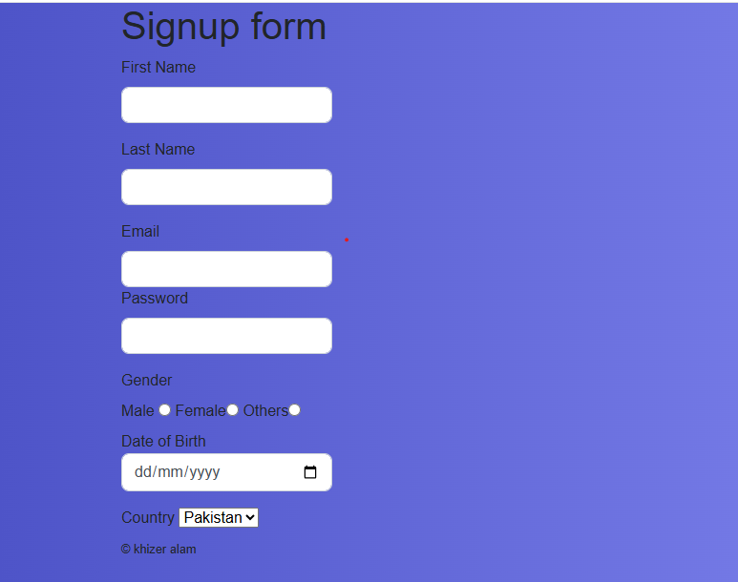

Lab # 5:

Objective:
Students will learn to create an interactive calculator using HTML, Bootstrap for styling, and JavaScript for functionality.

Learning Outcomes:
By completing this lab, students will be able to:
- Integrate JavaScript with HTML forms
- Use document.getElementById() to access input values
- Create JavaScript functions
- Handle button click events using onclick attribute
- Display results using alert() function
- Perform mathematical operations (addition, subtraction, multiplication, division)
- Apply Bootstrap classes for responsive design

Task Description:
Create a simple calculator web application that performs basic arithmetic operations on two numbers entered by the user.

Requirements:
- Document Setup:
  - Use HTML5 DOCTYPE with lang="en"
  - Include meta tags for charset (UTF-8)
  - Set page title as "Calculate"
  - Link Bootstrap CSS file: <link rel="stylesheet" href="../bootstrap/CSS/bootstrap.min.CSS">
  - Link Bootstrap JS file: <script src="../bootstrap/JS/bootstrap.bundle.min.JS"></script>
  - Add class="bg-light" to body tag
- Bootstrap Layout:
  - Use container class with mt-5
  - Create a row with justify-content-center class
  - Add one column with col-md-5 class
- Card Design:
  - Create a card with classes card shadow
  - Add card-body inside the card
  - Include centered heading "Calculator" with classes text-center mb-4
- Input Fields: Create two number input fields: a) Num 1:
  - Label with class form-label
  - Input with type="number", id="num1", class form-control
  - Wrap in div with class mb-3
- b) Num 2:
  - Label with class form-label
  - Input with type="number", id="num2", class form-control
  - Wrap in div with class mb-3
- Operation Buttons: Create 4 buttons for different operations, each with:
  - Wrap each button in div with classes w-100 text-center mt-2
  - Button classes: btn btn-success
  - type="button"
  - onclick attribute calling respective function
- The 4 buttons:
  - Sum button - onclick="sum()"
  - Subtract button - onclick="subtract()"
  - Division button - onclick="divison()"
  - Multiplication button - onclick="multiplication()"
- JavaScript Functions: Create 4 JavaScript functions inside <script> tags: a) sum() function:
  - Get values from num1 and num2 using document.getElementById().value
  - Convert to integer using parseInt()
  - Add the two numbers
  - Display result using alert("Addition = " + result)
- b) subtract() function:
  - Get values from num1 and num2
  - Subtract num2 from num1
  - Display result using alert("Subtraction = " + result)
- c) multiplication() function:
  - Get values from num1 and num2
  - Multiply the two numbers
  - Display result using alert("multiplication = " + result)
- d) divison() function:
  - Get values from num1 and num2
  - Divide num1 by num2
  - Display result using alert("Division = " + result)

JavaScript Concepts:
- document.getElementById("id") - Accesses HTML element by its id
- .value - Gets the value from an input field
- parseInt() - Converts string to integer
- parseFloat() - Converts string to Float
- alert() - Displays popup message with result
- onclick - Event handler that triggers when button is clicked

CODE:
<!DOCTYPE html>
<html lang="en">
<head>
<meta charset="UTF-8">
<title>Calculator</title>
</head>
<body>

<label>Value 1</label><br>
<input type="text" id="value1" value="10"><br><br>

<label>Value 2</label><br>
<input type="text" id="value2" value="5"><br><br>

<select id="operation">
<option value="add">ADD</option>
<option value="sub">SUB</option>
<option value="mul">MUL</option>
<option value="div">DIV</option>
</select>
<br><br>

<button onclick="calculate()">Calculate</button>

<h2 id="result"></h2>

<script>
function calculate() {
let v1 = parseFloat(document.getElementById("value1").value);
let v2 = parseFloat(document.getElementById("value2").value);
let op = document.getElementById("operation").value;
let res = 0;
if (op === "add") {
res = v1 + v2;
} else if (op === "sub") {
res = v1 - v2;
} else if (op === "mul") {
res = v1 * v2;
} else if (op === "div") {
res = v1 / v2;
}

document.getElementById("result").innerText = "Result = " + res;
}
</script>

</body>
</html>

SCREENSHOT:

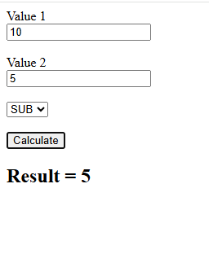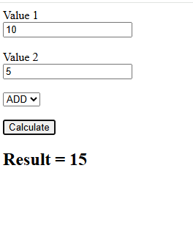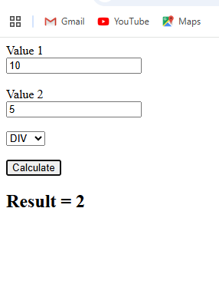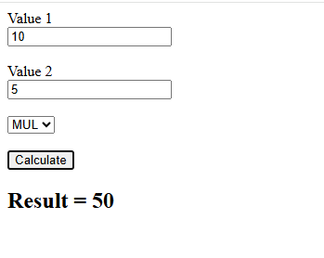

Lab # 6:
Objective: Students will learn to implement client-side form validation using JavaScript regular expressions (regex) to ensure data quality and user input accuracy.
Learning Outcomes: By completing this lab, students will be able to:
- Understand and apply regular expressions for input validation
- Use JavaScript test() method to validate patterns
- Display dynamic error messages based on validation results
- Access and manipulate DOM elements for error feedback
- Validate different data types (text, numbers, email)
- Implement conditional logic for form validation
- Use span elements to display inline error messages
- Apply Bootstrap styling to error messages
Task Description: Create a responsive form with real-time validation that checks user input against specific patterns and displays appropriate error messages when validation fails.
Requirements:
Document Setup:
- Use HTML5 DOCTYPE with lang="en"
- Include meta tags for charset (UTF-8) and viewport
- Set page title as "Simple Form"
- Link Bootstrap CSS file: <link rel="stylesheet" href="../bootstrap/CSS/bootstrap.min.CSS">
- Link Bootstrap JS file: <script src="../bootstrap/JS/bootstrap.bundle.min.JS"></script>
- Add class="bg-light" to body tag
Bootstrap Layout:
- Use container class with mt-5
- Create a row with justify-content-center class
- Add one column with col-md-6 class
Card Design:
- Create a card with classes card shadow
- Add centered heading "Form Validation" with class text-center
- Add card-body inside the card
Form Fields: Create 5 input fields with validation:
a) First Name:
- Label with class form-label
- Input with type="text", id="firstname", class form-control
- Error span with id="first_name_error" and class text-danger
- Wrap in div with class mb-3
b) Last Name:
- Label with class form-label
- Input with type="text", id="lastname", class form-control
- Error span with id="last_name_error" and class text-danger
- Wrap in div with class mb-3
c) Email:
- Label with class form-label
- Input with type="email", id="email", class form-control
- Error span with id="email_error" and class text-danger
- Wrap in div with class mb-3
d) Contact:
- Label with class form-label
- Input with type="number", id="contact", class form-control
- Error span with id="contact_error" and class text-danger
- Wrap in div with class mb-3
e) Salary:
- Label with class form-label
- Input with type="number", id="salary", class form-control
- Error span with id="salary_error" and class text-danger
- Wrap in div with class mb-3
Submit Button:
- Wrap button in div with class text-center
- Button with type="button", classes btn btn-primary
- onclick attribute calling validationregex() function
- Button text: "Submit"
JavaScript Validation Function:
Create the validationregex() function that performs the following validations:
1. First Name Validation:
- Get value using document.getElementById("firstname").value
- Check if field is not empty
- Apply regex pattern: /^[a-zA-Z]{1,100}$/ (only alphabets, 1-100 characters)
- Use .test() method to validate
- Display "Please write valid values" if pattern fails
- Display "Please write any value" if field is empty
- Clear error message if validation passes
2. Last Name Validation:
- Get value using document.getElementById("lastname").value
- Check if field is not empty
- Apply regex pattern: /^[a-zA-Z]{1,100}$/ (only alphabets, 1-100 characters)
- Display "Write valid values for name" if pattern fails
- Display "Write any value" if field is empty
- Clear error message if validation passes
3. Contact Validation:
- Get value using document.getElementById("contact").value
- Check if field is not empty
- Apply regex pattern: /^[0-9]{11}$/ (exactly 11 digits)
- Display "Enter valid 11-digit contact number" if pattern fails
- Display "Enter contact number" if field is empty
- Clear error message if validation passes
4. Salary Validation:
- Get value using document.getElementById("salary").value
- Check if field is not empty
- Apply regex pattern: /^[0-9]+$/ (only numbers, any length)
- Display "Enter valid salary" if pattern fails
- Display "Enter salary" if field is empty
- Clear error message if validation passes
Regular Expression Patterns Used:
- /^[a-zA-Z]{1,100}$/ - Validates alphabetic characters only, between 1 and 100 characters
- /^[0-9]{11}$/ - Validates exactly 11 numeric digits
- /^[0-9]+$/ - Validates one or more numeric digits
JavaScript Concepts:
- document.getElementById("id").value - Retrieves the value from an input field
- document.getElementById("id").innerHTML - Sets the content of an element
- Regular Expression .test() method - Tests if a string matches a pattern
- Conditional statements (if-else) - Controls validation logic
- String comparison operators (!=) - Checks if field is empty
Important Bootstrap Classes Used:
- Layout: container, row, col-md-6, justify-content-center, mt-5
- Form: form-label, form-control, mb-3
- Card: card, card-body, shadow
- Button: btn, btn-primary, text-center
- Text: text-danger (for error messages)
- Background: bg-light
Notes:
- Error messages appear in red below each input field using the text-danger class
- Validation occurs when the Submit button is clicked
- Each field is validated independently
- Error messages are cleared when validation passes
- The form uses client-side validation only (no data is actually submitted)
CODE:
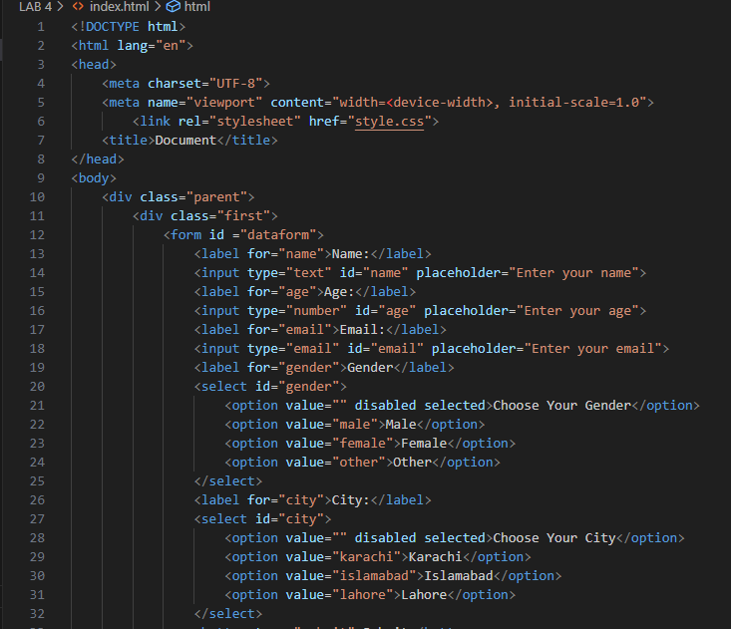
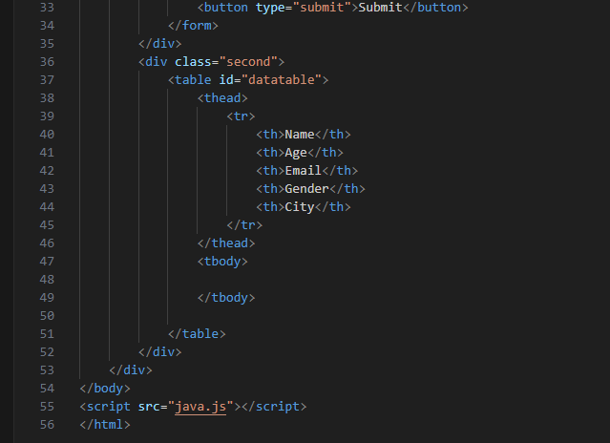
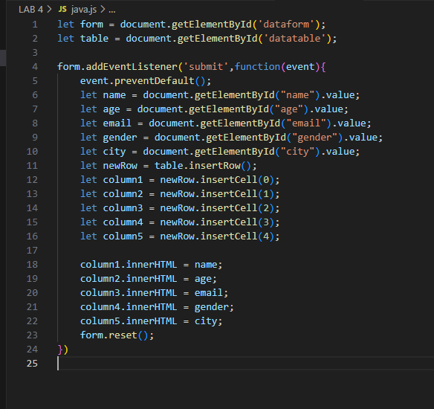

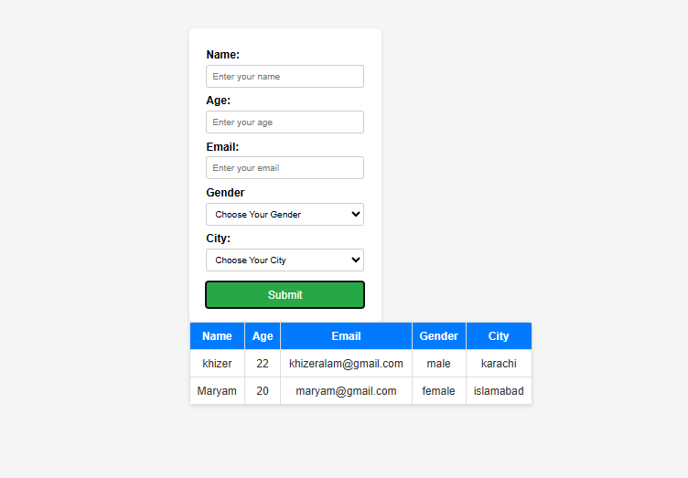

Lab # 7:
Objective: Students will learn to connect an HTML form to a MySQL database using PHP, enabling them to store user-submitted data persistently in a database.
Learning Outcomes: By completing this lab, students will be able to:
- Set up and use XAMPP server environment
- Create a MySQL database and table using PHPMyAdmin
- Connect PHP to MySQL database using mysqli
- Retrieve form data using PHP $_POST superglobal
- Insert data into MySQL database using SQL INSERT query
- Use the form action attribute to submit data to a PHP file
- Understand the relationship between HTML form attributes and PHP variables
- Process form submissions on the server-side

Task Description: Create a user registration form that collects user information and stores it in a MySQL database using PHP as the backend processing language.

Requirements:
Part 1: Database Setup
- Install and Start XAMPP:
  - Download and install XAMPP (includes Apache server, MySQL, and PHP)
  - Start Apache and MySQL services from XAMPP Control Panel
- Create Database in PHPMyAdmin:
  - Open PHPMyAdmin by visiting http://localhost/PHPmyadmin in your browser
  - Create a new database named wpl
  - Create a table named users with the following structure:
    - id (INT, PRIMARY KEY, AUTO_INCREMENT)
    - first_name (VARCHAR, 100)
    - last_name (VARCHAR, 100)
    - email (VARCHAR, 150)
    - password (VARCHAR, 255)
    - contact (VARCHAR, 20)
Part 2: HTML Form (index.HTML or index.PHP)
Document Setup:
- Use HTML5 DOCTYPE with lang="en"
- Include meta tags for charset (UTF-8), X-UA-Compatible, and viewport
- Set page title as "Document"
- Link Bootstrap CSS file: <link rel="stylesheet" href="bootstrap/CSS/bootstrap.min.CSS">
- Link Bootstrap JS file: <script src="bootstrap/JS/bootstrap.min.JS"></script>
Form Structure:
- Use container class for Bootstrap layout
- Create a form with method="post" and action="forrmSubmit.PHP"
- The action attribute specifies the PHP file that will process the form data
Form Fields: Create 5 input fields, each wrapped in a div with class form-group and inline style margin: 10px:
a) First Name:
- Label: "First Name"
- Input type="text", class="form-control", name="first_name"
- Placeholder: "Enter first name"
b) Last Name:
- Label: "Last Name"
- Input type="text", class="form-control", name="last_name"
- Placeholder: "Enter last name"
c) Email:
- Label: "Email"
- Input type="text", class="form-control", name="email"
- Placeholder: "Enter email"
d) Password:
- Label: "Password"
- Input type="password", class="form-control", name="password"
- Placeholder: "Enter password"
e) Contact:
- Label: "Contact"
- Input type="text", class="form-control", name="contact"
- Placeholder: "Enter contact"
Submit Button:
- Button type="submit", class="btn btn-primary"
- Inline style: margin: 10px
- Button text: "Submit"
Part 3: PHP Backend (forrmSubmit.PHP)
Retrieving Form Data: Create PHP variables to capture form data using the $_POST superglobal array. The keys in $_POST correspond to the name attributes in the HTML form:
PHP
$first_name = $_POST['first_name'];
$last_name = $_POST['last_name'];
$email = $_POST['email'];
$password = $_POST['password'];
$contact = $_POST['contact'];
Database Connection: Establish a connection to the MySQL database using mysqli_connect():
PHP
$conn = mysqli_connect('localhost', 'root', '', 'wpl');
Parameters:
- 'localhost' - Server hostname (local machine)
- 'root' - MySQL username (default XAMPP username)
- '' - Password (empty by default in XAMPP)
- 'wpl' - Database name
Inserting Data: Create an SQL INSERT query to add the form data to the users table:
PHP
$query = "INSERT INTO users(first_name, last_name, email, password, contact)
VALUES('$first_name', '$last_name', '$email', '$password', '$contact')";
Execute the query using mysqli_query():
PHP
mysqli_query($conn, $query);
Key Concepts:
1. Form Submission Flow:
- User fills out the HTML form
- User clicks Submit button
- Browser sends POST request to forrmSubmit.PHP
- PHP receives data via $_POST array
- PHP connects to database
- PHP inserts data into users table
- Data is stored persistently in database
2. HTML Name Attribute:
- The name attribute in HTML form inputs is crucial
- It creates the key in the $_POST array
- Example: <input name="first_name"> creates $_POST['first_name']
3. PHP $_POST Superglobal:
- Special array that contains all form data submitted via POST method
- Accessible from any PHP script
- Keys match the name attributes from the form
4. MySQLi Functions:
- mysqli_connect() - Establishes database connection
- mysqli_query() - Executes SQL queries
- Returns connection resource for database operations
5. SQL INSERT Statement:
- Used to add new records to a database table
- Syntax: INSERT INTO table_name(columns) VALUES(values)
- Column names must match database table structure
Important Notes:
- The form uses method="post" to securely send data to the server
- Password is stored in plain text (in production, use password_hash())
- This code is for learning purposes; in production, use prepared statements to prevent SQL injection
- Ensure XAMPP Apache and MySQL services are running before testing
- The form action points to the PHP file that processes the data
- Data persists in the database even after closing the browser
Testing the Application:
- Start XAMPP and ensure Apache and MySQL are running
- Place both files in the htdocs folder (C:\xampp\htdocs\your_project)
- Open browser and navigate to http://localhost/your_project/index.HTML
- Fill out the form and click Submit
- Check PHPMyAdmin to verify data was inserted into the users table
Bootstrap Classes Used:
- Layout: container
- Form: form-group, form-control
- Button: btn, btn-primary

CODE:
<!DOCTYPE html>
<HTML lang="en">

<head>
<meta charset="UTF-8">
<meta http-equiv="X-UA-Compatible" content="IE=edge">
<meta name="viewport" content="width=device-width, initial-scale=1.0">
<title>Document</title>
<script src="bootstrap/JS/bootstrap.min.JS"></script>
<link rel="stylesheet" href="bootstrap/CSS/bootstrap.min.CSS">
</head>

<body>
<div class="container">
<form method="post" action="forrmSubmit.PHP">

<div class="form-group" style="margin: 10px;">
<label for="">First Name</label>
<input type="text" class="form-control" name="first_name" placeholder="Enter first name">
</div>
<div class="form-group" style="margin: 10px;">
<label>Last Name</label>
<input type="text" class="form-control" name="last_name" placeholder="Enter last name">
</div>
<div class="form-group" style="margin: 10px;">
<label>Email</label>
<input type="text" class="form-control" name="email" placeholder="Enter email">
</div>
<div class="form-group" style="margin: 10px;">
<label>Password</label>
<input type="password" class="form-control" name="password" placeholder="Enter password">
</div>
<div class="form-group" style="margin: 10px;">
<label>Password</label>
<input type="password" class="form-control" name="password" placeholder="Enter password">
</div>
<div class="form-group" style="margin: 10px;">
<label>Contact</label>
<input type="text" class="form-control" name="contact" placeholder="Enter contact">
</div>
<button type="submit" class="btn btn-primary" style="margin: 10px;">Submit</button>
</form>
</div>
<script>
</script>
</body>

</HTML>

<?php
$first_name = $_POST['first_name'];
$last_name = $_POST['last_name'];
$email = $_POST['email'];
$password = $_POST['password'];
$contact = $_POST['contact'];

$conn = mysqli_connect('localhost', 'root', '', 'wpl');
$query = "INSERT INTO users(first_name,last_name,email,password,contact) values('$first_name','$last_name','$email','$password','$contact')";
mysqli_query($conn, $query);

SCREENSHOTS:
XAMP PANEL:

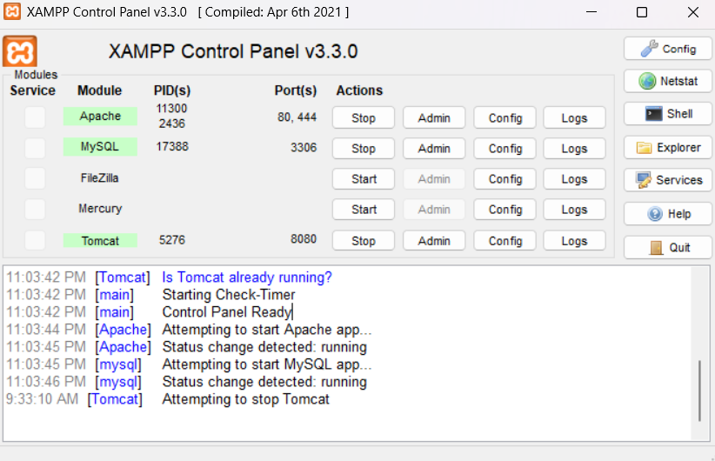

DASHBOARD ACCESS USING LOCALHOST:80 or any port use configure:

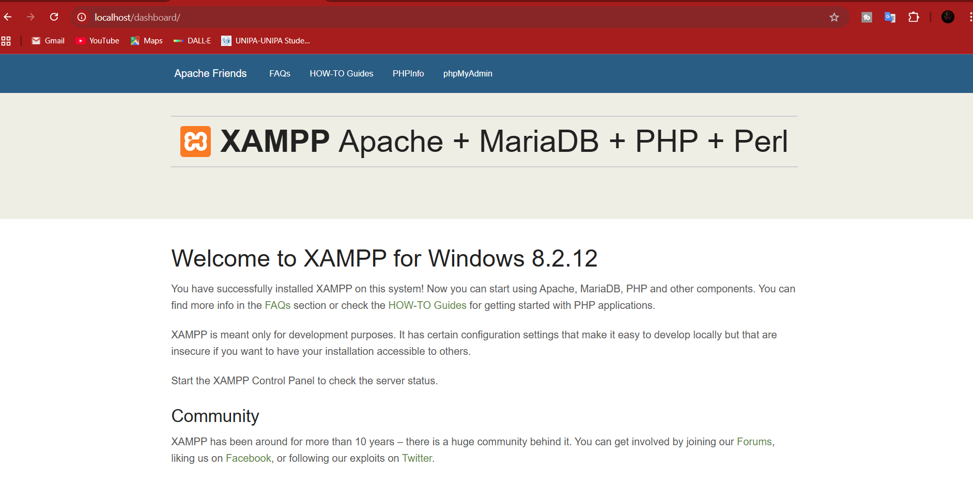

USERFORM:

SENDING FORM DATA TO MYSQL USING BACKEND BY FETCHING DATA FROM FRONTEND: ACCESS DATABASE FROM PHPMYADMIN

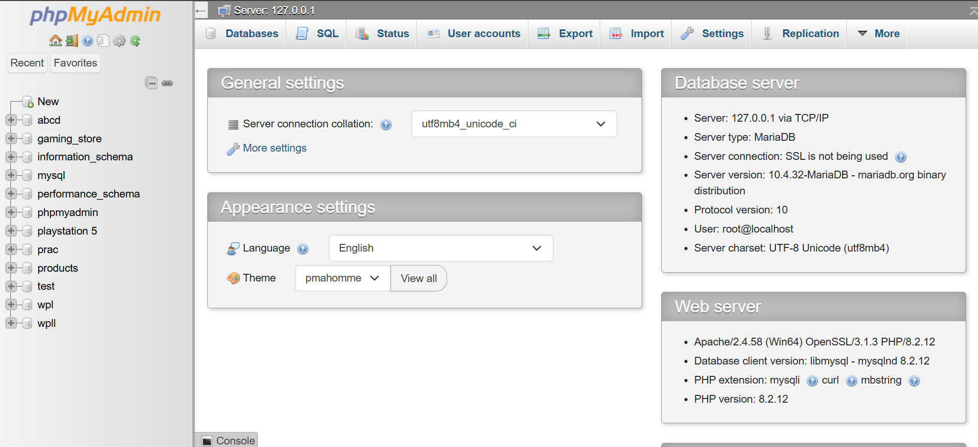
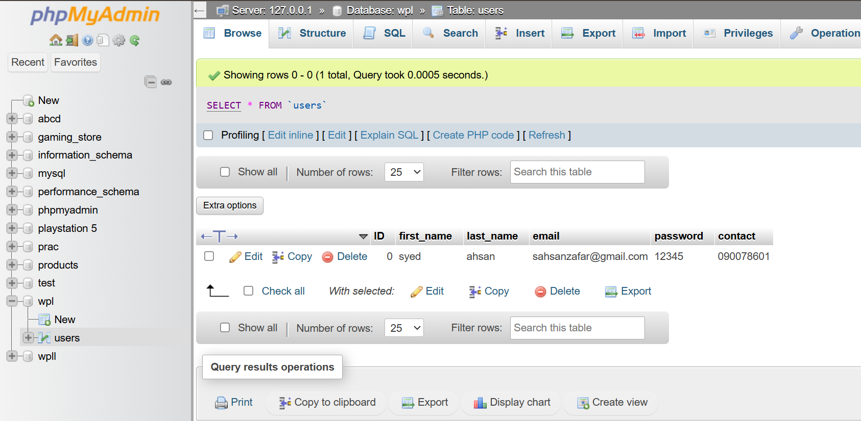

Lab # 8:
Objective: Students will learn to perform CRUD (Create, Read, Update, Delete) operations on a MySQL database using PHP. In this lab, we focus on the Create and Read operations to insert and display product data.
Learning Outcomes: By completing this lab, students will be able to:
- Create a product entry form and insert data into MySQL database
- Retrieve and display all records from a database table
- Use mysqli_fetch_all() to fetch multiple rows as an associative array
- Display database records in an HTML table with Bootstrap styling
- Implement page redirection using PHP header() function
- Use query parameters in URLs for passing data between pages
- Create dynamic links for Edit and Delete actions
- Apply Bootstrap table classes for enhanced styling
Task Description: Create a complete product management system that allows users to add new products through a form and view all products in a formatted table with action buttons for future edit and delete operations.
Requirements:
Part 1: Database Setup
- Create Database in PHPMyAdmin:
  - Open PHPMyAdmin at http://localhost/PHPmyadmin
  - Create a new database named products
  - Create a table named product with the following structure:
    - product_id (INT, PRIMARY KEY, AUTO_INCREMENT)
    - product_name (VARCHAR, 150)
    - product_category (VARCHAR, 100)
    - product_quantity (INT)
    - product_price (DECIMAL, 10, 2)
Part 2: Product Form (form.PHP)
Document Setup:
- Use HTML5 DOCTYPE with lang="en"
- Include meta tags for charset (UTF-8) and viewport
- Set page title as "Document"
- Link Bootstrap CSS file: <link rel="stylesheet" href="bootstrap/CSS/bootstrap.min.CSS">
- Link Bootstrap JS file: <script src="bootstrap/JS/bootstrap.bundle.min.JS"></script>
Bootstrap Layout:
- Use container class for main wrapper
- Create a row using class row
- Add one column with class col-6 (takes 50% width)
Card Design:
- Create a card with classes card and d-flex justify-content-start
- Add card-body inside the card
- Include heading "product form" using h1 tag
Form Structure:
- Create form with method="post" and action="formsubmit.PHP"
- Wrap each input in a div with class form-group
Form Fields: Create 4 input fields for product information:
a) Product Name:
- Label: "product name"
- Input type="text", name="product_name", id="product_name"
- class="form-control"
b) Product Category:
- Label: "product category"
- Input type="text", name="product_category", id="product_category"
- class="form-control"
c) Product Quantity:
- Label: "product quantity"
- Input type="number", name="product_quantity", id="product_quantity"
- class="form-control"
d) Product Price:
- Label: "product price"
- Input type="text", name="product_price", id="product_price"
- class="form-control"
Submit Button:
- Wrap button in div with classes d-flex justify-content-center
- Input type="submit", class="btn btn-primary", value="submit"
Part 3: Form Processing (formsubmit.PHP)
Retrieving Form Data: Capture all product information from the form using $_POST:
PHP
$product_name = $_POST['product_name'];
$product_category = $_POST['product_category'];
$product_quantity = $_POST['product_quantity'];
$product_price = $_POST['product_price'];
Database Connection: Connect to the products database:
PHP
$connection = mysqli_connect('localhost', 'root', '', 'products');
Insert Query: Create SQL INSERT statement to add the product to the database:
PHP
$query = "INSERT INTO product(product_name, product_category, product_quantity, product_price)
VALUES('$product_name', '$product_category', '$product_quantity', '$product_price')";
Execute Query: Run the query to insert data:
PHP
mysqli_query($connection, $query);
Page Redirection: Redirect user to the table display page after successful insertion:
PHP
header('Location: tableshow.PHP');
Part 4: Display Products Table (tableshow.PHP)
PHP Section - Fetching Data:
- Database Connection:
PHP
$connection = mysqli_connect('localhost', 'root', '', 'products');
- Select Query: Create SQL SELECT statement to retrieve all products:
PHP
$query = "SELECT * FROM product";
- Execute Query: Run the query and store the result:
PHP
$result = mysqli_query($connection, $query);
- Fetch All Records: Convert result into an associative array:
PHP
$data = mysqli_fetch_all($result, MYSQLI_ASSOC);
HTML Section - Document Setup:
- Use HTML5 DOCTYPE with lang="en"
- Include meta tags for charset (UTF-8), X-UA-Compatible, and viewport
- Set page title as "Document"
- Link Bootstrap CSS and JS files
Add Product Button:
- Wrap button in div with classes d-flex justify-content-center
- Create anchor tag linking to form.PHP
- Use classes btn btn-primary
- Button text: "ADD PRODUCT"
Table Structure: Create a table with classes: table table-bordered table-hover table-striped
Table Headers:
- Sr (Product ID)
- Product Category
- Product Name
- Product Price
- Product Quantity
- Action
Table Body - Dynamic Data Display:
Use PHP for loop to iterate through all fetched records:
PHP
for($i=0; $i<count($data); $i++){
For each product, create a table row with:
- Product ID: <?PHP echo $data[$i]['product_id'] ?>
- Product Name: <?PHP echo $data[$i]['product_name'] ?>
- Product Category: <?PHP echo $data[$i]['product_category'] ?>
- Product Quantity: <?PHP echo $data[$i]['product_quantity'] ?>
- Product Price: <?PHP echo $data[$i]['product_price'] ?>
Action Buttons: In the Action column, add two buttons:
- Edit Button:
  - Anchor tag with href="editform.PHP?product_id=<?PHP echo $data[$i]['product_id']?>"
  - class="btn btn-primary"
  - Button text: "edit"
  - Passes product_id as query parameter
- Delete Button:
  - Anchor tag with href="delete.PHP?product_id=<?PHP echo $data[$i]['product_id']?>"
  - class="btn btn-danger"
  - Button text: "delete"
  - Passes product_id as query parameter
Key Concepts:
1. CRUD Operations:
- Create: Insert new product records (formsubmit.PHP)
- Read: Fetch and display all products (tableshow.PHP)
- Update: Edit existing records (editform.PHP - prepared for future lab)
- Delete: Remove records (delete.PHP - prepared for future lab)
2. MySQLi Functions:
- mysqli_connect() - Establishes database connection
- mysqli_query() - Executes SQL queries
- mysqli_fetch_all() - Fetches all result rows as an array
- MYSQLI_ASSOC - Returns associative array with column names as keys
3. PHP header() Function:
- Used for page redirection
- Must be called before any output is sent to browser
- Syntax: header('Location: filename.PHP')
4. Query Parameters:
- Pass data through URL using ?parameter=value
- Example: editform.PHP?product_id=5
- Retrieved using $_GET['product_id']
5. PHP Loops for Dynamic Content:
- for loop iterates through array
- count($data) returns number of records
- Each iteration displays one product row
6. Associative Arrays:
- Access data using column names as keys
- Example: $data[$i]['product_name']
- Makes code more readable and maintainable
Bootstrap Table Classes:
- table - Base table styling
- table-bordered - Adds borders to all cells
- table-hover - Adds hover effect on rows
- table-striped - Alternating row colors for better readability
Application Flow:
- User navigates to tableshow.PHP → sees all products
- User clicks "ADD PRODUCT" button → redirected to form.PHP
- User fills product form and clicks Submit
- Data sent to formsubmit.PHP → inserted into database
- User automatically redirected back to tableshow.PHP
- Updated product list displayed with new entry
- Edit and Delete buttons prepared for future functionality
CODE:
<!DOCTYPE HTML>
<html lang="en">
<head>
<meta charset="UTF-8">
<title>Product Form</title>
<link rel="stylesheet" href="bootstrap/CSS/bootstrap.min.css">
</head>
<body>

<div class="container">
<div class="row justify-content-center">
<div class="col-6">
<div class="card mt-5">
<div class="card-body">
<h3>Product Form</h3>

<form action="formsubmit.php" method="post">
<div class="form-group">
<label>Product Name</label>
<input type="text" name="product_name" class="form-control">
</div>

<div class="form-group">
<label>Product Category</label>
<input type="text" name="product_category" class="form-control">
</div>

<div class="form-group">
<label>Product Quantity</label>
<input type="number" name="product_quantity" class="form-control">
</div>

<div class="form-group">
<label>Product Price</label>
<input type="text" name="product_price" class="form-control">
</div>

<div class="text-center">
<input type="submit" class="btn btn-primary" value="Submit">
</div>
</form>

</div>
</div>
</div>
</div>
</div>

</body>
</html>

<?php
$connection = mysqli_connect('localhost','root','','products');

$product_name = $_POST['product_name'];
$product_category = $_POST['product_category'];
$product_quantity = $_POST['product_quantity'];
$product_price = $_POST['product_price'];

$query = "INSERT INTO product(product_name,product_category,product_quantity,product_price)
VALUES('$product_name','$product_category','$product_quantity','$product_price')";

mysqli_query($connection, $query);

header("Location: tableshow.php");
?>

<?php
$connection = mysqli_connect('localhost','root','','products');
$query = "SELECT * FROM product";
$result = mysqli_query($connection,$query);
$data = mysqli_fetch_all($result, MYSQLI_ASSOC);
?>

<!DOCTYPE HTML>
<html lang="en">
<head>
<meta charset="UTF-8">
<title>Product List</title>
<link rel="stylesheet" href="bootstrap/CSS/bootstrap.min.css">
</head>
<body>

<div class="container mt-4">
<div class="text-center mb-3">
<a href="form.php" class="btn btn-primary">ADD PRODUCT</a>
</div>

<table class="table table-bordered table-hover table-striped">
<thead>
<tr>
<th>ID</th>
<th>Product Name</th>
<th>Category</th>
<th>Quantity</th>
<th>Price</th>
</tr>
</thead>
<tbody>

<?php foreach($data as $row){ ?>
<tr>
<td><?php echo $row['product_id']; ?></td>
<td><?php echo $row['product_name']; ?></td>
<td><?php echo $row['product_category']; ?></td>
<td><?php echo $row['product_quantity']; ?></td>
<td><?php echo $row['product_price']; ?></td>
</tr>
<?php } ?>
</tbody>
</table>
</div>

</body>
</html>

SCREENSHOT:
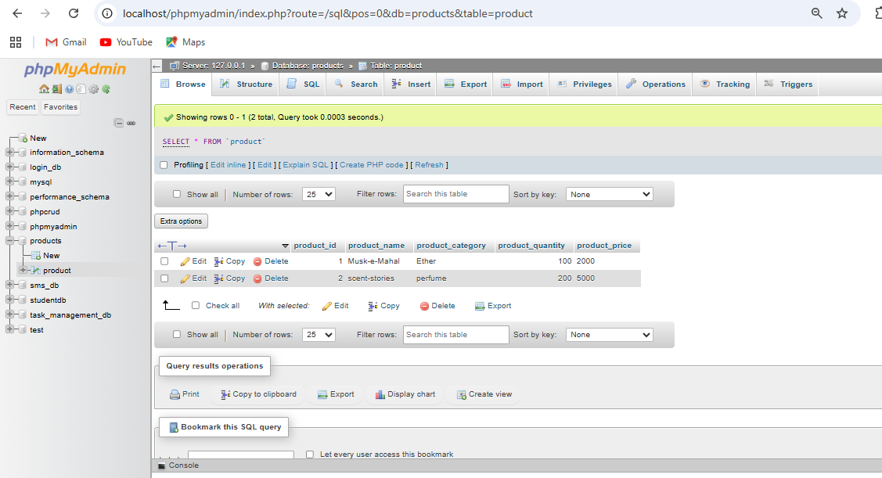

Lab #9:
Objective: Students will learn to complete the CRUD operations by implementing Update and Delete functionality. This lab focuses on editing existing product records and removing products from the database.
Learning Outcomes: By completing this lab, students will be able to:
- Retrieve specific records using WHERE clause in SQL
- Pre-populate form fields with existing database values
- Use hidden input fields to maintain product ID during updates
- Execute SQL UPDATE queries to modify existing records
- Execute SQL DELETE queries to remove records from database
- Pass data between pages using URL query parameters ($_GET)
- Handle both $_GET and $_POST methods in PHP
- Implement complete CRUD functionality in a web application
Task Description: Complete the product management system by adding the ability to edit existing products and delete unwanted products from the database.
Requirements:
Part 1: Edit Form (editform.PHP)
PHP Section - Fetching Single Product:
- Retrieve Product ID from URL:
PHP: $id = $_GET["product_id"];
- Gets the product_id passed through URL query parameter
- This ID identifies which product to edit

- Database Connection:
PHP: $connection = mysqli_connect('localhost', 'root', '', 'products');
- Select Specific Product: Create SQL query to fetch only the product with matching ID:
PHP: $query = "SELECT * FROM product WHERE product_id=$id";
- WHERE clause filters results to single product
- Uses the ID from URL parameter

- Execute Query:
PHP: $result = mysqli_query($connection, $query);
- Fetch Product Data:
PHP: $data = mysqli_fetch_all($result, MYSQLI_ASSOC);
- Returns associative array with product information
- Even though only one record, still returns as array
HTML Section - Document Setup:
- Use HTML5 DOCTYPE with lang="en"
- Include meta tags for charset (UTF-8) and viewport
- Set page title as "Document"
- Link Bootstrap CSS file: <link rel="stylesheet" href="bootstrap/CSS/bootstrap.min.CSS">
- Link Bootstrap JS file: <script src="bootstrap/JS/bootstrap.bundle.min.JS"></script>
Bootstrap Layout:
- Use container class for main wrapper
- Create a row using class row
- Add one column with class col-6
Card Design:
- Create card with classes card and d-flex justify-content-start
- Add card-body inside the card
- Include heading "product form" using h1 tag
Form Structure:
- Create form with method="post" and action="editformsubmit.PHP"
- Form will submit updated data to processing file
Form Fields with Pre-populated Values:
a) Product ID (Hidden Field):
PHP:
<input type="hidden" value="<?PHP echo $data[0]['product_id']?>"
name="product_id" id="product_id" class="form-control">
- Hidden input field that stores product ID
- Not visible to user but submitted with form
- Essential for identifying which record to update
- Label included but field is hidden
b) Product Name:
- Label: "product name"
- Input type="text", name="product_name", id="product_name"
- value="<?PHP echo $data[0]['product_name']?>"
- Pre-filled with current product name from database
- class="form-control"
c) Product Category:
- Label: "product category"
- Input type="text", name="product_category", id="product_category"
- value="<?PHP echo $data[0]['product_category']?>"
- Pre-filled with current category
- class="form-control"
d) Product Quantity:
- Label: "product quantity"
- Input type="number", name="product_quantity", id="product_quantity"
- value="<?PHP echo $data[0]['product_quantity']?>"
- Pre-filled with current quantity
- class="form-control"
e) Product Price:
- Label: "product price"
- Input type="text", name="product_price", id="product_price"
- value="<?PHP echo $data[0]['product_price']?>"
- Pre-filled with current price
- class="form-control"
Submit Button:
- Wrap button in div with classes d-flex justify-content-center
- Input type="submit", class="btn btn-primary", value="submit"

Part 2: Update Processing (editformsubmit.PHP)
Retrieving Updated Form Data: Capture all updated product information including the product ID:
PHP:
$id = $_POST['product_id'];
$product_name = $_POST['product_name'];
$product_category = $_POST['product_category'];
$product_quantity = $_POST['product_quantity'];
$product_price = $_POST['product_price'];
Database Connection:
PHP: $connection = mysqli_connect('localhost', 'root', '', 'products');
SQL UPDATE Query: Create UPDATE statement to modify the existing record:
PHP:
$query = "UPDATE product SET
product_name = '$product_name',
product_category = '$product_category',
product_quantity = '$product_quantity',
product_price = '$product_price'
WHERE product_id = '$id'";
Query Structure Breakdown:
- UPDATE product - Specifies the table to update
- SET - Keyword to specify which columns to update
- column_name = 'new_value' - Sets new values for each column
- WHERE product_id = '$id' - Critical: identifies which specific record to update
- Without WHERE clause, ALL records would be updated
Execute Update Query:
PHP: mysqli_query($connection, $query);
Page Redirection: Redirect back to products table after successful update:
PHP: header('Location: tableshow.PHP');
Part 3: Delete Processing (delete.PHP)
Retrieving Product ID: Get the product ID from URL parameter:
PHP: $id = $_GET['product_id'];
- Product ID passed when user clicks delete button
- Identifies which product to remove
Database Connection:
PHP: $connection = mysqli_connect('localhost', 'root', '', 'products');
SQL DELETE Query: Create DELETE statement to remove the record:
PHP: $query = "DELETE FROM product WHERE product_id = '$id'";
Query Structure:
- DELETE FROM product - Specifies table to delete from
- WHERE product_id = '$id' - Critical: identifies which record to delete
- Without WHERE clause, ALL records would be deleted
Execute Delete Query:
PHP: $result = mysqli_query($connection, $query);
Page Redirection: Redirect back to products table after deletion:
PHP: header('Location: tableshow.PHP');
Key Concepts:
1. Complete CRUD Operations:
- Create: Insert new records (Lab 8 - formsubmit.PHP)
- Read: Display all records (Lab 8 - tableshow.PHP)
- Update: Modify existing records (editform.PHP + editformsubmit.PHP)
- Delete: Remove records (delete.PHP)
2. SQL UPDATE Statement:
- Modifies existing data in database
- Syntax: UPDATE table SET column1=value1, column2=value2 WHERE condition
- WHERE clause is essential to update specific record
- Multiple columns can be updated in single query
3. SQL DELETE Statement:
- Removes records from database
- Syntax: DELETE FROM table WHERE condition
- WHERE clause prevents deleting all records
- Permanent operation - cannot be undone
4. Hidden Input Fields:
- Store data that needs to be submitted but not displayed
- type="hidden" makes field invisible to user
- Essential for passing IDs in update operations
- Maintains data integrity during form submission
5. Pre-populating Form Fields:
- Uses value attribute with PHP echo
- Displays current database values in form
- Allows user to see and modify existing data
- Syntax: value="<?PHP echo $data[0]['column_name']?>"
6. GET vs POST Methods:
- $_GET: Retrieves data from URL query parameters
  - Visible in URL (e.g., editform.PHP?product_id=5)
  - Used for fetching data to display/edit
- $_POST: Retrieves data from form submission
  - Not visible in URL
  - Used for sensitive operations like updates
7. Array Indexing:
- $data[0] accesses first record in array
- Even single records returned as array from mysqli_fetch_all()
- Column names used as keys: $data[0]['product_name']
Application Flow:
Update Flow:
- User clicks "edit" button in tableshow.PHP
- Browser navigates to editform.PHP?product_id=X
- editform.PHP fetches product data using ID from URL
- Form displays with pre-filled current values
- User modifies desired fields and clicks Submit
- Data sent to editformsubmit.PHP via POST
- UPDATE query modifies database record
- User redirected to tableshow.PHP to see changes

SCREENSHOT:
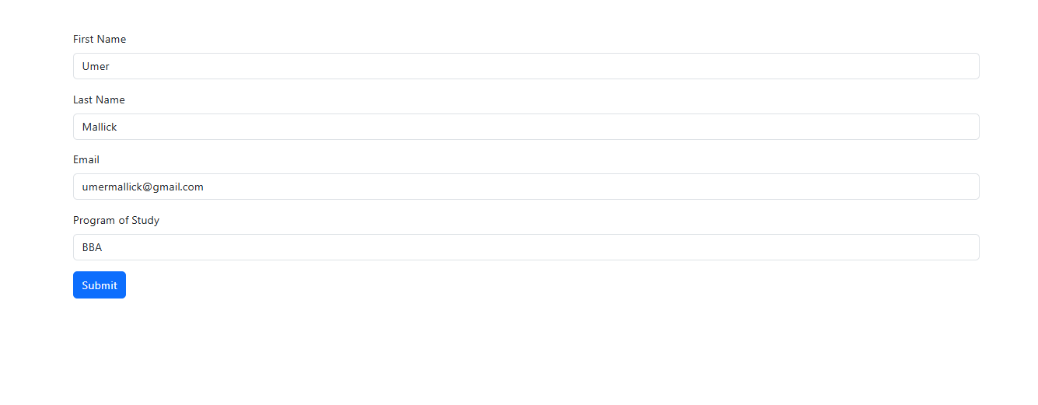
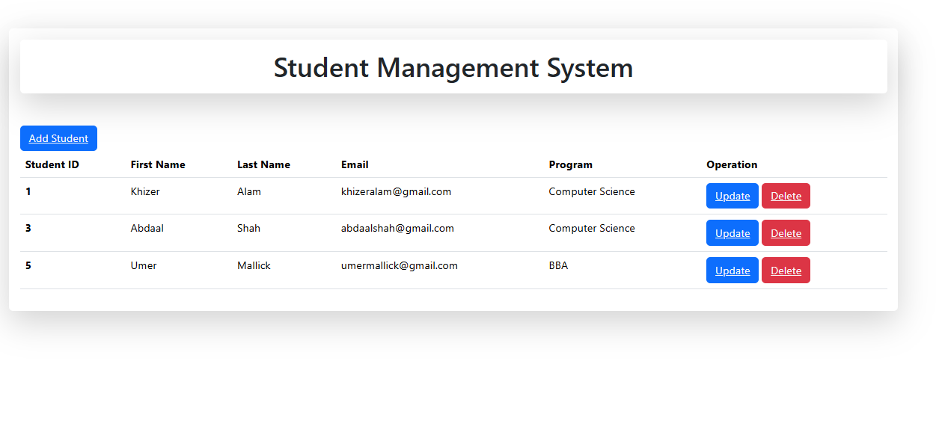

CODE:
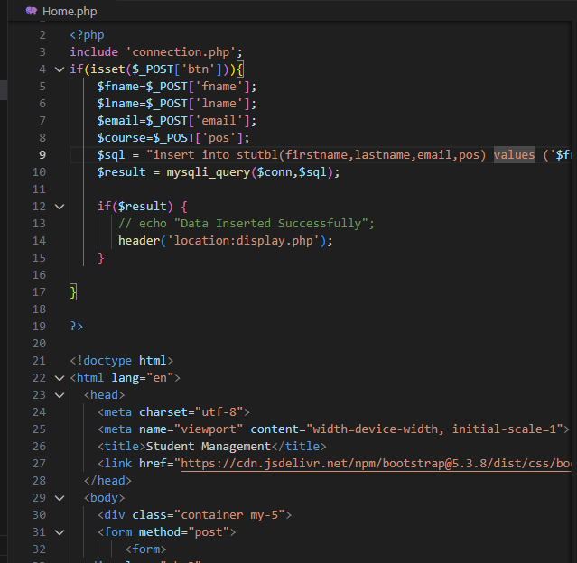
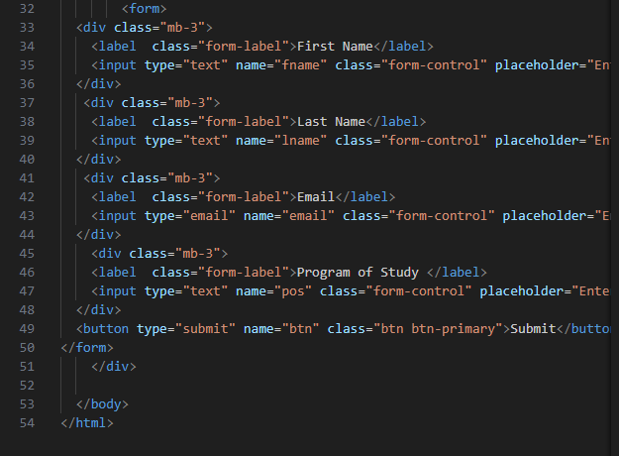
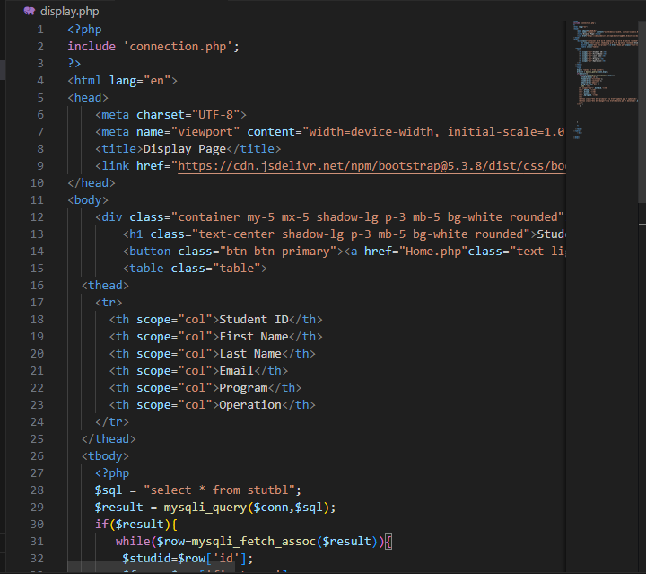
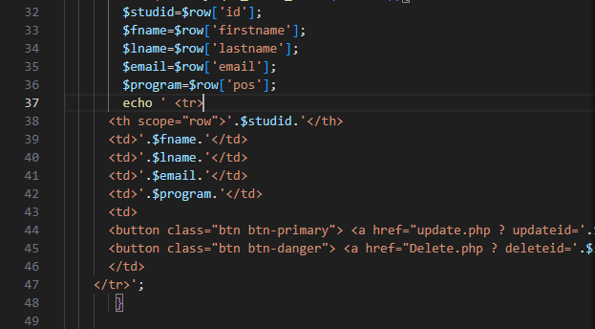
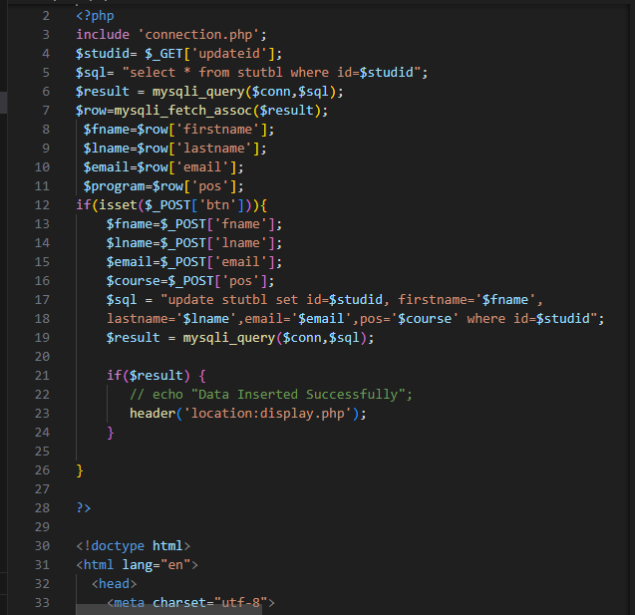
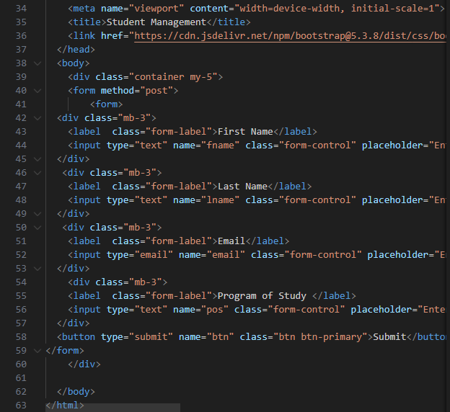
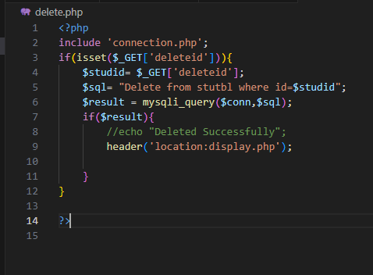
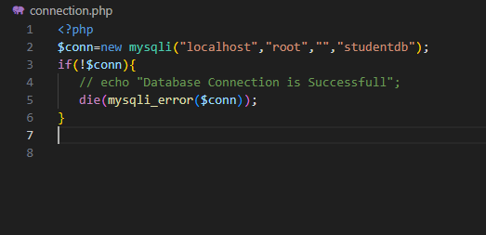

Lab #10:

Objective
Students will learn to implement asynchronous data submission using AJAX (Asynchronous JavaScript and XML) with jQuery, allowing form data to be sent to the server without page reload.

Learning Outcomes
By completing this lab, students will be able to:
- Understand AJAX concepts and asynchronous programming
- Use jQuery library for AJAX requests
- Prevent default form submission behavior
- Collect form data using jQuery selectors
- Create JSON objects from form inputs
- Send POST requests asynchronously to PHP backend
- Handle AJAX success and error callbacks
- Reload page content dynamically
- Debug AJAX requests using console.log()
- Integrate AJAX with existing PHP/MySQL applications

Task Description
Create a product entry form that submits data to the server using AJAX, eliminating page refresh and providing a smoother user experience.

Requirements

Part 1: Database Setup
Ensure you have the existing setup from previous labs:
- Database: products
- Table: product with columns:
  - product_id (INT, PRIMARY KEY, AUTO_INCREMENT)
  - product_name (VARCHAR, 150)
  - product_category (VARCHAR, 100)
  - product_type (INT or VARCHAR, 100)
  - product_price (DECIMAL, 10, 2)

Part 2: Main HTML File (index.PHP)

File Structure
Create index.PHP with the following structure:
PHP
<?PHP
$conn = mysqli_connect('localhost', 'root', '', 'products');
include 'main.HTML';
?>
Explanation:
- Establishes database connection at the start
- Includes main.HTML file which contains Bootstrap and jQuery links
- Connection stored in $conn variable for use throughout application

HTML Document Setup
HTML
<HTML>

<head>
<title>CRUD WITH AJAX</title>
</head>

<body>
Head Section: The main.HTML file (included above) should contain:
- Bootstrap CSS link
- jQuery library link (required for AJAX)
- Bootstrap JavaScript bundle

Bootstrap Layout
HTML
<div class="container mt-3">
<div class="row col-12 g-3">
<div class="col col-md-6">
Classes Explained:
- container - Bootstrap container for responsive layout
- mt-3 - Margin top: 3
- row - Bootstrap row
- col-12 - Full width column
- g-3 - Gutters spacing: 3
- col col-md-6 - Column that takes half width on medium+ screens

Form Section
Form Heading:
HTML
<h3 class="text-center">Form</h3>
- text-center - Centers the text
Form Element:
HTML
<form id="form">
- No action or method attributes (handled by AJAX)
- id="form" for jQuery selection
Form Fields:
a) Product Name:
HTML
<div class="input-group mt-4 mb-4">
<label>product name</label>
<input name="p_name" id="p_name" type="text" class="form-control">
</div>
b) Product Category:
HTML:
<div class="input-group mb-4">
<label>product category</label>
<input name="p_category" id="p_category" type="text" class="form-control">
</div>
c) Product Type:
HTML:
<div class="input-group mb-4">
<label>product type</label>
<input name="p_type" id="p_type" type="number" class="form-control">
</div>

d) Product Price:
HTML:
<div class="input-group mb-4">
<label>product price</label>
<input name="p_price" id="p_price" type="number" class="form-control">
</div>
Submit Button:
HTML:
<button class="btn btn-primary w-100" id="btn" type="submit">Submit</button>
Classes Explained:
- btn - Bootstrap button base class
- btn-primary - Blue primary button style
- w-100 - Width 100% (full width)
- type="submit" - Triggers form submission
Close Tags:
HTML:
</form>
</div>
</div>
</div>

Part 3: JavaScript/jQuery AJAX Implementation

Document Ready Function
Wraps all jQuery code to ensure DOM is fully loaded:
javascript
<script>
$(document).ready(function() {
// Code executes after page loads completely
Explanation:
- $(document).ready() - Waits for HTML to fully load before running code
- Ensures all elements exist before JavaScript tries to access them

Form Submit Event Handler
Attach Submit Event:
javascript
$('#form').on('submit', function(e) {
- $('#form') - Selects the form by ID
- .on('submit', ...) - Attaches event listener to form submission
- e - Event object containing information about the submit event
Prevent Default Submission:
javascript
e.preventDefault()
- Stops normal form submission behavior
- Prevents page reload
- Allows AJAX to handle submission instead

Create JSON Object
javascript
let JSonFile = {
'p_name': $('#p_name').val(),
'p_category': $('#p_category').val(),
'p_type': $('#p_type').val(),
'p_price': $('#p_price').val(),
}
Explanation:
- Creates JavaScript object with form data
- $('#p_name').val() - Retrieves value from input field with ID p_name
- Keys match the input names for PHP processing
- Object will be sent to server

Console Logging (Debugging)
javascript
console.log(JSonFile)
- Displays data object in browser console
- Useful for debugging and verifying data before sending
- Can be removed in production

AJAX Request
javascript
$.ajax({
type: 'POST',
url: 'create.PHP',
data: JSonFile,
success: function(response) {
location.reload()
console.log(response)
},
error: function(error) {
console.log(error)
}
})
AJAX Parameters Explained:
1. type: 'POST'
- HTTP method for request
- POST is secure for sending data
- Data not visible in URL
2. url: 'create.PHP'
- Destination PHP file that will process the data
- Relative path to the processing script
3. data: JSonFile
- The data object to send to server
- jQuery automatically converts to URL-encoded format
- Accessible in PHP via $_POST array
4. success: function(response)
- Callback function executed when request succeeds
- response contains data returned from PHP
- location.reload() - Refreshes the page to show new data
- console.log(response) - Displays server response in console
5. error: function(error)
- Callback function executed if request fails
- error contains error information
- console.log(error) - Helps debug issues
Close Functions:
javascript
})
})
</script>

Close HTML:
HTML:
</body>

</HTML>

Part 4: PHP Backend Processing (create.PHP)
Create a new file called create.PHP:
PHP:
<?PHP
$conn = mysqli_connect('localhost', 'root', '', 'products');

$p_name = $_POST['p_name'];
$p_category = $_POST['p_category'];
$p_type = $_POST['p_type'];
$p_price = $_POST['p_price'];

$query = "INSERT INTO product(product_name, product_category, product_type, product_price)
VALUES('$p_name', '$p_category', '$p_type', '$p_price')";

$result = mysqli_query($conn, $query);

if($result) {
echo "Product added successfully";
} else {
echo "Error: " . mysqli_error($conn);
}
?>
Code Breakdown:
1. Database Connection:
PHP:
$conn = mysqli_connect('localhost', 'root', '', 'products');
- Connects to MySQL database
- Parameters: hostname, username, password, database name
2. Retrieve POST Data:
PHP:
$p_name = $_POST['p_name'];
$p_category = $_POST['p_category'];
$p_type = $_POST['p_type'];
$p_price = $_POST['p_price'];
- $_POST - Superglobal array containing data sent via POST
- Keys match the JSON object keys from AJAX
3. SQL Query:
PHP:
$query = "INSERT INTO product(product_name, product_category, product_type, product_price)
VALUES('$p_name', '$p_category', '$p_type', '$p_price')";
- INSERT statement to add new row
- Values come from POST data

4. Execute Query:
PHP:
$result = mysqli_query($conn, $query);
- Executes the SQL query
- Returns TRUE on success, FALSE on failure
5. Response Handling:
PHP:
if($result) {
echo "Product added successfully";
} else {
echo "Error: " . mysqli_error($conn);
}
- Sends response back to AJAX success/error callback
- mysqli_error() provides error details if query fails

Key Concepts

1. AJAX (Asynchronous JavaScript and XML)
- Allows sending/receiving data without page reload
- Creates better user experience
- Reduces server load and bandwidth
- Enables dynamic content updates
- Works asynchronously in background

2. jQuery Library
- JavaScript library that simplifies AJAX
- Provides $.ajax() method for easy requests
- Handles cross-browser compatibility
- Simplifies DOM manipulation and event handling

3. Event Handling
- .on('submit', ...) - Attaches event listener
- Waits for user to submit form
- Triggers custom function instead of default behavior

4. preventDefault()
- Stops default browser behavior
- For forms: prevents page refresh and navigation
- Allows custom JavaScript handling
- Essential for AJAX form submissions

5. jQuery Selectors
- $('#id') - Selects element by ID
- .val() - Gets or sets input value
- Similar to document.getElementById() but shorter

6. JSON Object
- JavaScript Object Notation
- Key-value pairs for data structure
- Easy to create, read, and transmit
- Automatically converted by jQuery for transmission

7. Callback Functions
- Functions executed after AJAX completes
- success: runs when request succeeds
- error: runs when request fails
- Handles asynchronous responses

8. location.reload()
- JavaScript method to refresh current page
- Updates displayed data after insertion
- Alternative: update DOM without full reload

Application Flow
- Page loads with empty form
- User fills in product information
- User clicks Submit button
- JavaScript prevents normal form submission
- jQuery collects all input values
- Data packaged into JSON object
- AJAX sends POST request to create.PHP
- PHP receives data via $_POST

PHP inserts data into database
<?php include('header.php');?>

<div class="container my-5">
<h2 class="text-center">Student Management (AJAX Version)</h2>

<div class="card p-4 shadow-sm">
<div class="mb-3">
<label>First Name</label>
<input type="text" id="fname" class="form-control" placeholder="First Name">
</div>
<div class="mb-3">
<label>Email</label>
<input type="email" id="email" class="form-control" placeholder="Email">
</div>
<button type="button" id="addBtn" class="btn btn-primary">Add Student</button>
</div>

<table class="table mt-5">
<thead>
<tr>
<th>ID</th><th>Name</th><th>Email</th><th>Action</th>
</tr>
</thead>
<tbody id="studentTable">
</tbody>
</table>
</div>

<script src="https://code.jquery.com/jquery-3.6.0.min.js"></script>

<script>
$(document).ready(function(){

function loadData(){
$.ajax({
url: "fetch.php",
success: function(data){
$('#studentTable').html(data);
}
});
}
loadData();

$('#addBtn').click(function(){
var fname = $('#fname').val();
var email = $('#email').val();

$.ajax({
url: "insert.php",
method: "POST",
data: { f: fname, e: email },
success: function(res){
alert(res);
$('#fname').val('');
$('#email').val('');
loadData();
}
});

}
});
});

$(document).on('click', '.del-btn', function(){
var id = $(this).data('id');
if(confirm("Delete karna hai?")){
$.ajax({
url: "delete_ajax.php",
method: "POST",
data: { id: id },
success: function(res){
loadData();
}
});
}
});
});
</script>

<?php include('footer.php'); ?>

<?php
include 'connection.php';

$sql = "select * from stutbl";
$res = mysqli_query($conn, $sql);

while($row = mysqli_fetch_assoc($res)){
echo "<tr>
<td>{$row['id']}</td>
<td>{$row['firstname']}</td>
<td>{$row['email']}</td>
<td><button class='btn btn-danger del-btn' data-id='{$row['id']}'>Delete</button></td>
</tr>";
}
?>

<?php
$conn = new mysqli("localhost","root","","studentdb");
if(!$conn){ die(mysqli_error($conn)); }
?>

<?php
include 'connection.php';

$fname = $_POST['f'];
$email = $_POST['e'];

$sql = "insert into stutbl(firstname, email) values ('$fname', '$email')";
if(mysqli_query($conn, $sql)){
echo "Student Added Successfully!";
} else {
echo "Error!";
}
?>

LAB 11
MASTER TEMPLATE

CODE:
<?php
session_start();
if (isset($_SESSION['role']) && isset($_SESSION['id']) ) {

include "DB_connection.php";
include "app/Model/Task.php";
include "app/Model/User.php";

if ($_SESSION['role'] == "admin") {
$todaydue_task = count_tasks_due_today($conn);
$overdue_task = count_tasks_overdue($conn);
$nodeadline_task = count_tasks_NoDeadline($conn);
$num_task = count_tasks($conn);
$num_users = count_users($conn);
$pending = count_pending_tasks($conn);
$in_progress = count_in_progress_tasks($conn);
$completed = count_completed_tasks($conn);
}else {
$num_my_task = count_my_tasks($conn, $_SESSION['id']);
$overdue_task = count_my_tasks_overdue($conn, $_SESSION['id']);
$nodeadline_task = count_my_tasks_NoDeadline($conn, $_SESSION['id']);
$pending = count_my_pending_tasks($conn, $_SESSION['id']);
$in_progress = count_my_in_progress_tasks($conn, $_SESSION['id']);
$completed = count_my_completed_tasks($conn, $_SESSION['id']);

}
?>
<!DOCTYPE html>
<html>
<head>
<title>Dashboard</title>

<link rel="stylesheet" href="https://stackpath.bootstrapcdn.com/font-awesome/4.7.0/css/font-awesome.min.css">
<link rel="stylesheet" href="css/style.css">
</head>
<body>
<input type="checkbox" id="checkbox">
<?php include "inc/header.php" ?>
<div class="body">
<?php include "inc/nav.php" ?>
<section class="section-1">
<?php if ($_SESSION['role'] == "admin") { ?>
<div class="dashboard">
<div class="dashboard-item">
<i class="fa fa-users"></i>
<span><?=$num_users?> Employee</span>
</div>
<div class="dashboard-item">
<i class="fa fa-tasks"></i>
<span><?=$num_task?> All Tasks</span>
</div>
<div class="dashboard-item">
<i class="fa fa-window-close-o"></i>
<span><?=$overdue_task?> Overdue</span>
</div>
<div class="dashboard-item">
<i class="fa fa-clock-o"></i>
<span><?=$nodeadline_task?> No Deadline</span>
</div>
<div class="dashboard-item">
<i class="fa fa-exclamation-triangle"></i>
<span><?=$todaydue_task?> Due Today</span>

</div>
<div class="dashboard-item">
<i class="fa fa-bell"></i>
<span><?=$overdue_task?> Notifications</span>
</div>
<div class="dashboard-item">
<i class="fa fa-square-o"></i>
<span><?=$pending?> Pending</span>
</div>
<div class="dashboard-item">
<i class="fa fa-spinner"></i>
<span><?=$in_progress?> In progress</span>
</div>
<div class="dashboard-item">
<i class="fa fa-check-square-o"></i>
<span><?=$completed?> Completed</span>
</div>
</div>
<?php }else{ ?>
<div class="dashboard">
<div class="dashboard-item">
<i class="fa fa-tasks"></i>
<span><?=$num_my_task?> My Tasks</span>
</div>
<div class="dashboard-item">

</div>
<div class="dashboard-item">
<i class="fa fa-clock-o"></i>
<span><?=$nodeadline_task?> No Deadline</span>
</div>
<div class="dashboard-item">
<i class="fa fa-square-o"></i>
<span><?=$pending?> Pending</span>
</div>
<div class="dashboard-item">
<i class="fa fa-spinner"></i>
<span><?=$in_progress?> In progress</span>
</div>
<div class="dashboard-item">
<i class="fa fa-check-square-o"></i>
<span><?=$completed?> Completed</span>
</div>
</div>
<?php } ?>
</section>
</div>

<script type="text/javascript">
var active = document.querySelector("#navList li:nth-child(1)");
active.classList.add("active");
</script>
</body>
</html>
<?php }else{
$em = "First login";
header("Location: login.php?error=$em");
exit();
}
?>

SCREENSHOT:

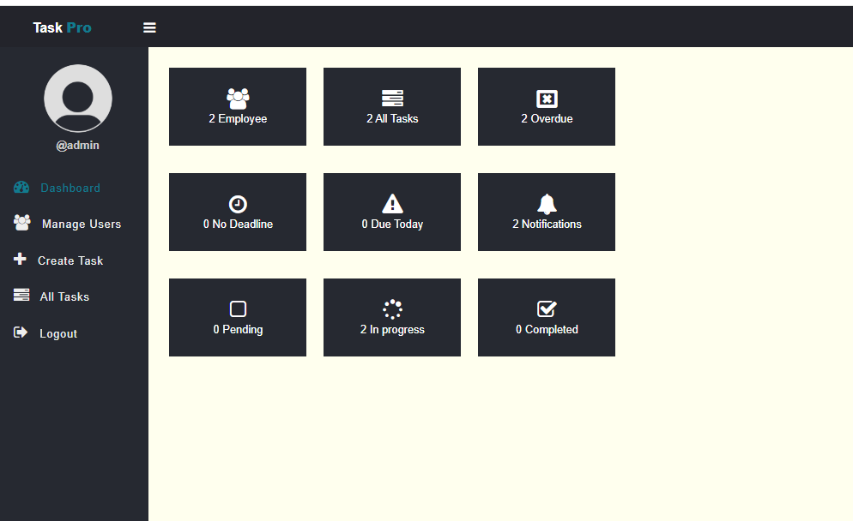
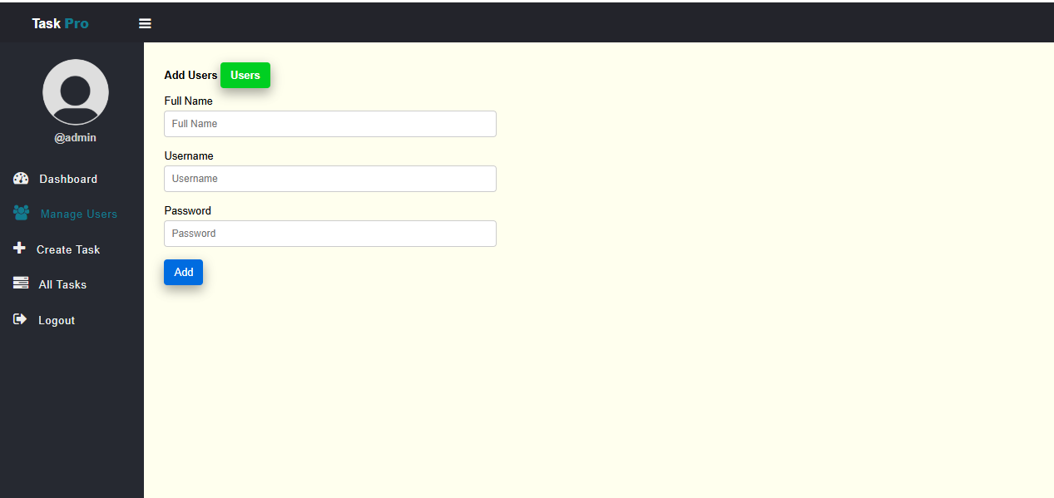
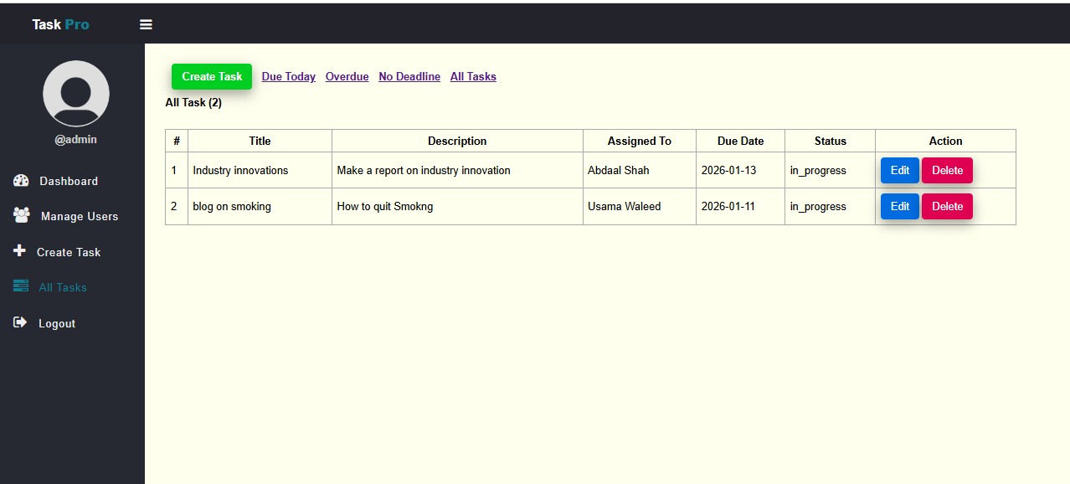

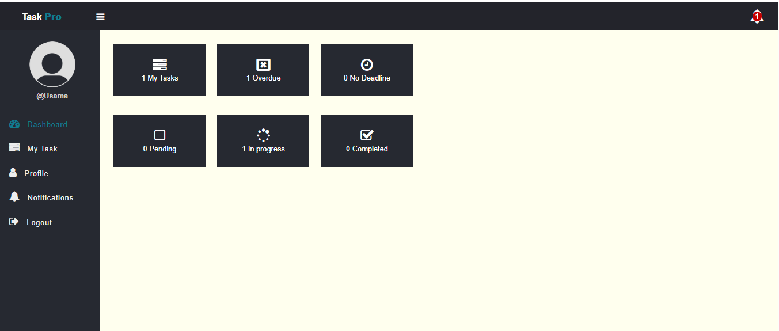

LAB 12

GITHUB:

COMMANDS:
git init
git add .
git commit -m ""
git remote add origin https://github.com/khizeralam192-byte/khizer-Alam-IU04-0321-0519.git
git push

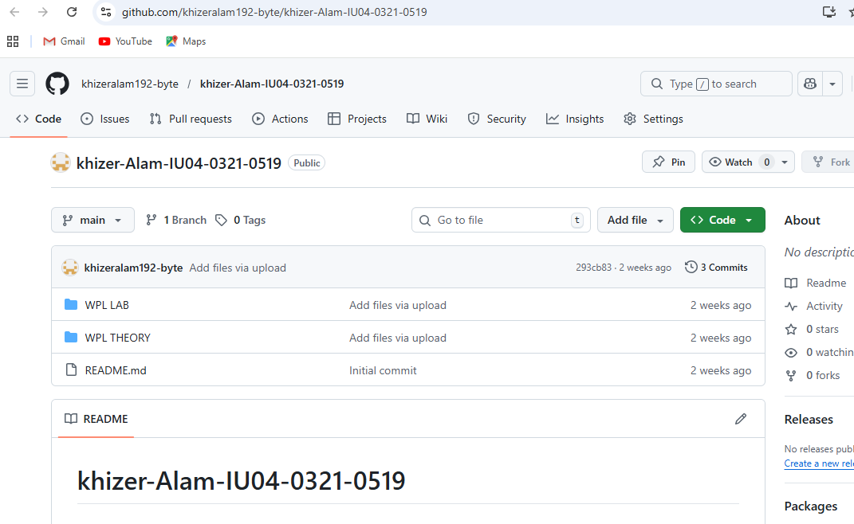

LAB 13
PBL USING SQL INJECTION

<?php
include 'connection.php';

if(isset($_POST['btn'])){
$fname=$_POST['fname'];
$lname=$_POST['lname'];
$email=$_POST['email'];
$course=$_POST['pos'];

$stmt = $conn->prepare(
"INSERT INTO stutbl(firstname,lastname,email,pos) VALUES (?,?,?,?)"
);
$stmt->bind_param("ssss",$fname,$lname,$email,$course);
$stmt->execute();

header('location:display.php');
}
?>

<!doctype html>
<html>
<body>
<div class="container my-5">
<form method="post">
<input type="text" name="fname" class="form-control mb-2" placeholder="First Name">
<input type="text" name="lname" class="form-control mb-2" placeholder="Last Name">
<input type="email" name="email" class="form-control mb-2" placeholder="Email">
<input type="text" name="pos" class="form-control mb-2" placeholder="Program">
<button type="submit" name="btn" class="btn btn-primary">Submit</button>
</form>
</div>
</body>
</html>

<?php include 'connection.php'; ?>
<html>
<body>
<a href="Home.php">Add Student</a>

<table border="1">
<tr>
<th>ID</th>
<th>First</th>
<th>Last</th>
<th>Email</th>
<th>Program</th>
<th>Action</th>
</tr>

<?php
$stmt = $conn->prepare("SELECT * FROM stutbl");
$stmt->execute();
$result = $stmt->get_result();

while($row = $result->fetch_assoc()){
echo "<tr>
<td>{$row['id']}</td>
<td>{$row['firstname']}</td>
<td>{$row['lastname']}</td>
<td>{$row['email']}</td>
<td>{$row['pos']}</td>
<td>
<a href='update.php?updateid={$row['id']}'>Update</a> |
<a href='delete.php?deleteid={$row['id']}'>Delete</a>
</td>
</tr>";
}

?>
</table>
</body>
</html>

<?php
include 'connection.php';

$studid = $_GET['updateid'];

$stmt = $conn->prepare("SELECT * FROM stutbl WHERE id=?");
$stmt->bind_param("i",$studid);
$stmt->execute();
$row = $stmt->get_result()->fetch_assoc();

if(isset($_POST['btn'])){
$fname=$_POST['fname'];
$lname=$_POST['lname'];
$email=$_POST['email'];
$course=$_POST['pos'];

$up = $conn->prepare(
"UPDATE stutbl SET firstname=?,lastname=?,email=?,pos=? WHERE id=?"
);
$up->bind_param("ssssi",$fname,$lname,$email,$course,$studid);
$up->execute();

header('location:display.php');
}
?>

<form method="post">
<input name="fname" value="<?php echo $row['firstname']; ?>"><br>
<input name="lname" value="<?php echo $row['lastname']; ?>"><br>
<input name="email" value="<?php echo $row['email']; ?>"><br>
<input name="pos" value="<?php echo $row['pos']; ?>"><br>
<button name="btn">Update</button>
</form>

<?php
include 'connection.php';

$studid = $_GET['deleteid'];

$stmt = $conn->prepare("DELETE FROM stutbl WHERE id=?");
$stmt->bind_param("i",$studid);
$stmt->execute();

header('location:display.php');
?>

<?php
$conn = new mysqli("localhost","root","","studentdb");
if($conn->connect_error){
die("Connection Failed");
}
?>

